FF All-New Futurist Ultra User Manual_V3.2
Contents
Welcome
1. Important Notice
1.1 Safety Precautions
1.2 Safety Guidelines
2. FF All-New Futurist Ultra Overview
2.1 Unpacking List
2.2 Product Introduction
2.2.1 Component Names and Descriptions
2.2.2 Robot Indicator Lights
2.2.3 Battery Indicator
2.2.3.1 Location of Battery Indicator Lights
2.2.3.2 Indicator Status Description (Working)
2.2.3.3 Indicator Status Description (Charging)
2.2.4 User Debugging Interfaces
2.3 Robot Joint Motion Range
2.4 Robot Sensor Field of View
2.5 Robot Specifications
2.6 Radio Frequency Specifications
3. Introduction to Remote Control
3.1 Remote Control Exterior Design
3.2 Remote Control Button Layout
3.3 Remote Control Charging Instructions
4. Usage Instructions
4.1 App
4.1.1 General Guide (How to Connect the Robot)
4.2 Startup Procedure
4.2.1 Packaging Box Startup
4.2.2 Power On in Supine Position
4.2.3 Power On in Prone Position
4.3 Shutdown Procedure
4.3.1 Shutdown and Packing
4.3.2 Shutdown with Supine Position
4.4 Entering and Exiting Battery Pack Storage Mode
4.4.1 Enter Storage Mode
4.4.2 Exit Storage Mode
4.5 Charging and Battery Changing
4.5.1 Charging Mode
4.5.2 Battery Changing Mode
4.5.3 Autonomous Charging
4.5.3.1 Functional Overview
4.5.3.2 Preparation
4.5.3.2.1 Deploying the Charging Point
4.5.3.2.2 Enabling Autonomous Charging
4.5.3.3 Autonomous Charging
4.5.3.3.1 Starting Autonomous Charging
4.5.3.3.2 Ending Autonomous Charging
4.5.3.3.3 Interrupting Autonomous Charging
4.5.3.4 Troubleshooting Quick Reference
4.5.3.5 Precautions
4.6 Emergency Stop Function
4.6.1 Triggering the Soft Emergency Stop
4.6.2 Emergency Stop Settings
4.7 Lifting Ring Installation
5. Function Description
5.1 Full-Body Dance
5.2 Body Actions
5.2.1 Upper-Limb Actions
5.2.2 Upper-Limb Compliant Motion Playback (Passive Safety)
5.2.3 Upper-Limb Motion Perception-Based Obstacle Stop (Active Safety)
5.3 Navigation and Obstacle Avoidance
5.4 Lively Standby
5.5 Robot Interaction
5.6 Spatial Tasks
5.6.1 Mapping and Point Marking
5.6.2 Post-Deployment Verification
5.6.3 Client Trigger Method
5.7 Fleet Control
5.7.1 How to Obtain
5.7.2 Project Management
5.7.3 Robot Management
5.7.4 Menu Bar
5.7.5 Audio
5.7.6 Automatic Tasks
5.7.6.1 Roles
5.7.6.2 Task Orchestration
5.7.6.3 Create / Edit Tasks
5.7.6.4 Execute / Cancel Tasks
6. Accessories Management and Usage
6.1 4G/5G Module User Guide
6.1.1 eSIM Usage Instructions
6.1.2 SIM Card Specifications
6.1.3 SIM Card Purchase
6.1.4 SIM Card Insertion
7. Daily Maintenance and Management
8. After-sales Service Policy
8.1 Warranty Content
8.2 App Privacy Policy

Welcome
Thank you for choosing the FF All-New Futurist Ultra Robot.
This user manual helps you fully understand and quickly get started with the FF All-New Futurist Ultra Robot (hereinafter referred to as "the Robot"), and provides detailed information on operation and maintenance to ensure an optimal user experience. Should you have any problems during use, please call our service hotline or contact our official WeChat account. Our professional technical support team will be glad to assist you.
Read User Manual: https://robotics-instruction-manual.ff.com/futurist
Contact After-sales Service: https://support.ff.com/us/

1. Important Notice

1.1 Safety Precautions
1. Know the Product: Before using the Robot for the first time, please read the manual to fully understand its functions, operating procedures, and all safety instructions.
2. Environmental Requirements: Operate the robot only on flat, dry and stable surfaces. Do not use it in environments with extreme high or low temperatures, high humidity, steep slopes, sharp drops, fragile ground or strong vibration.
3. Regular Inspection and Maintenance: Conduct regular maintenance and status checks on the Robot, focusing on key components such as joints, sensors, and the power system, to ensure the equipment remains in good working condition and to prevent safety hazards caused by component aging or damage.
4. Know the Emergency Stop Operations: Before use, familiarize yourself with the emergency stop operation method to halt the robot promptly in case of emergencies. Once the emergency stop is activated, all robot joints will lose support and collapse. For this reason, strictly observe on-site safety regulations and keep the protective frame in place at all times after an emergency stop. Do not activate the emergency stop unless necessary.
5. Reserve Operating Space: Before operation, ensure sufficient surrounding space for the robot to move. Do not use it in overly narrow areas or spaces crowded with people and obstacles, to prevent collision and pinching risks.
6. Electrical Safety: Before power-on, inspect cables, plugs and sockets to confirm they are intact and free of abnormalities. If a short circuit, overheating or other faults are detected, cut off the power supply immediately.
7. Prohibit Improper Use: Use the robot only in compliant and proper application scenarios. Do not operate it for dangerous, illegal or unauthorized purposes.
8. Confirm the Parking Location: Before entering the operating area, personnel must ensure that the robot is parked on level ground. Do not approach the robot while it is on a slope.
9. Restart after Shutdown: After shutting down, wait at least 30 seconds before powering the robot back on.

1.2 Safety Guidelines
1. Pre-Operation Checks
• a. Before powering on the robot or initiating any movement, ensure no personnel, debris or obstacles remain in the working area, especially around robotic arms, joints and other moving parts, to prevent collisions and personal injury.
• b. Operators shall inspect the robot for normal status before startup and confirm the completion of system self-check.
2. Standardized Operation and Training Requirements
All operating personnel must receive operating training in advance. Operators shall be familiar with the robot's specifications, standard operating procedures and exception handling protocols, to avoid safety risks arising from improper operation.
3. Maintain a Safe Distance
Keep a minimum 1 meter safe distance from the robot's working area during operation to prevent collision hazards caused by sudden equipment movement. Do not stay within the robot's predicted motion path, especially during high-speed operation.
4. Prohibition of Manual Intervention During Operation
Do not manually interfere with the robot while it is running. If adjustment, maintenance or manual handling is required, confirm the robot has come to a complete stop and is fully powered off before any operation.
5. Load and Component Usage Requirements
• a. Operate the robot within its rated load capacity. Do not apply loads exceeding its designed specification limits.
• b. When using end-effectors, grippers and other functional components, ensure full compatibility with the target workpiece. Mismatched components may cause extrusion, abnormal stress or permanent part damage.
6. Shutdown Procedures for Abnormal Conditions
In the event of abnormalities, malfunctions or unexpected faults, immediately activate emergency shutdown via the remote control to stop all robot motions without delay.
8. Remote Control Precautions
• a. If the robot is equipped with remote control functions, operate it only under stable and secure network conditions. Network interruptions, latency or external intrusion will impair control stability.
• b. Remote operators shall adopt real-time monitoring measures to continuously keep track of the robot's running status and on-site environment, so as to ensure the safety of remote operation.

2. FF All-New Futurist Ultra Overview

2.1 Unpacking List
No. | Component Name | Quantity
1 | Robot Main Body | 1
2 | Battery Charger | 1
3 | Magnetic Charging Connector | 1
4 | Remote Control | 1
5 | Protective Helmet | 1
6 | Lavalier Microphone | 1
7 | Quick Start Guide | 1
8 | Qualification Certificate | 1
9 | Safety Lanyard | 2
10 | Lifting Rings | 2
11 | Silicone Hand (Fist Gesture) | 2
12 | Accessory Kit | 1

2.2 Product Introduction
The FF All-New Futurist series products feature 31 to 71 degrees of freedom (varies by model and configuration), enabling flexible movement and high-precision posture control. The following details the specific configuration and feature highlights of the FF All-New Futurist Ultra.
• FF All-New Futurist Ultra: 2 degrees of freedom in the neck, 7 per arm, 3 in the waist, and 6 per leg.
• The perception system is equipped with front-view RGB stereo cameras, surround-view triple fisheye cameras, LiDAR, GPS RTK, UWB positioning, shoulder touch sensors, a chest RGB-D camera, and a hip RGB-D camera.
• The communication system is equipped with Wi-Fi, 4G/5G mobile network, and Bluetooth.
• The interaction system is equipped with omnidirectional microphones, speakers, a curved display, and omnidirectional indicator lights.
• The power system is equipped with a 1152Wh battery, providing a total battery life of 8 hours, including 4 hours of standing operation and over 4 hours of continuous walking. It supports direct charging, battery changing, with a charging time of ≤2 hours.

2.2.1 Component Names and Descriptions
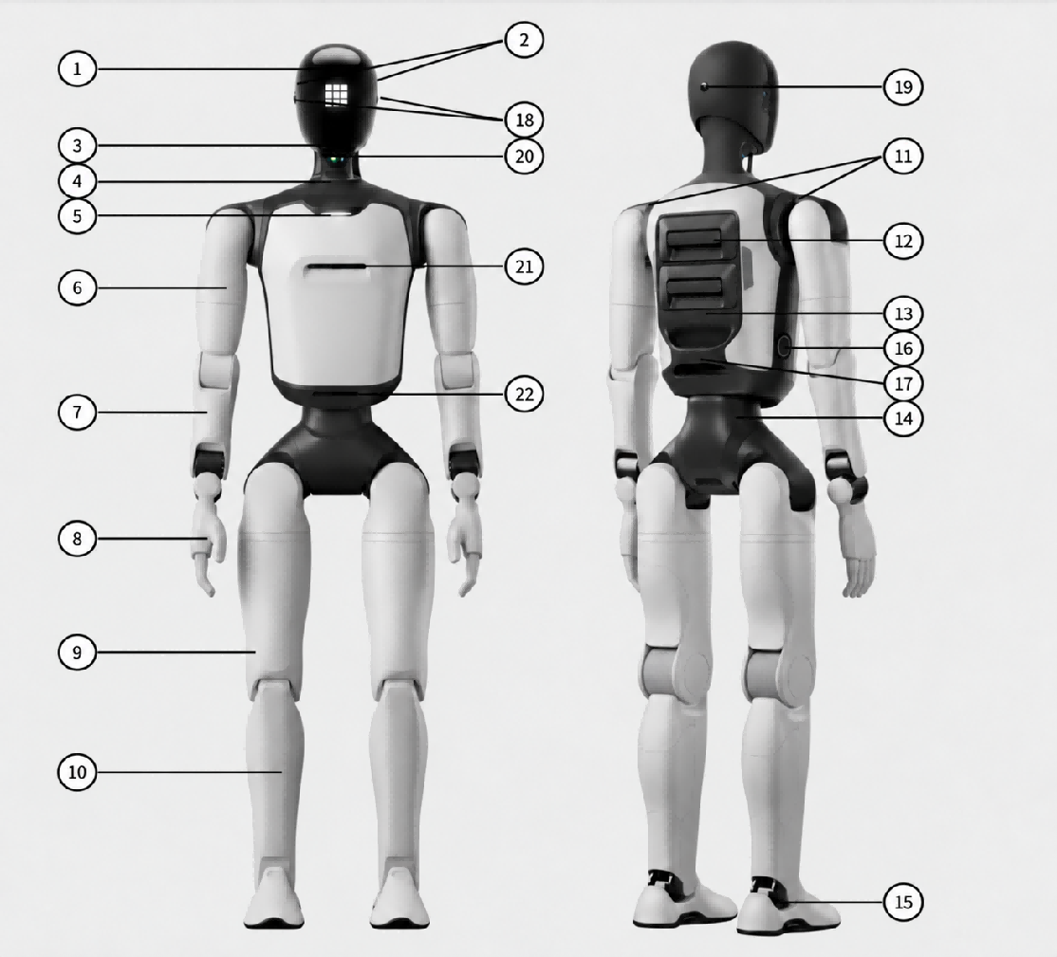
No. | Component | No. | Component | No. | Component
1 | Head Display | 9 | Thigh | 17 | Waist Handle
2 | Left and Right Speakers | 10 | Calf | 18 | Left and Right Fisheye Cameras
3 | Interactive Binocular Camera | 11 | Dual Shoulder Touch Sensors | 19 | Rear-View Fisheye Camera
4 | Switch | 12 | Dual Battery Compartments | 20 | LiDAR
5 | Microphone | 13 | Maintenance Bay | 21 | Chest RGB-D Camera
6 | Upper Arm | 14 | Waist | 22 | Hip RGB-D Camera
7 | Forearm | 15 | Foot
8 | Dexterous Hand | 16 | Charging Port

2.2.2 Robot Indicator Lights
The robot displays its current status through the head screen expressions, the chest light, and the ear lights. The chest light mainly indicates the robot's operating, battery and fault status; the ear lights mainly indicate real-time interaction states such as listening and speaking.
Category | Status | Description | Light Effect
Chest Light – Daily Status | Resting | When the robot is lifted up and no other status is triggered | Light off
 | Standby | The robot is powered on and waiting for user operation | Solid white
 | Charging | The robot is charging and not yet fully charged | Breathing white
 | Working | The robot is performing tasks such as navigation, guiding, delivery, dancing, or combat | Solid white
Voice Interaction | Listening | The robot is receiving the user's voice | Flowing white
 | Speaking | The robot is performing voice interaction tasks such as conversation, guiding, or skill expression.  Note: non-voice-interaction scenarios such as dancing, system announcements, and audio announcements triggered from the client do not trigger this light effect | Flowing white
Reminders and Faults | Find Robot | The user is locating the robot via the client | Red strobe (300 ms)
 | Critical Fault | A critical fault has occurred. Stop using the robot immediately and inspect it according to the system prompts | Solid red
 | Device Locked | The robot has entered the locked state
 | Emergency Stop | Manual intervention for an out-of-control or dangerous situation of the robot
 | Fault | A fault has occurred and must be handled according to the system prompts | Does not affect the light effect
 | Warning | A condition requiring attention has occurred; for example, when one battery is removed, the robot displays the warning light effect
 | Low Battery | When the combined level of "both batteries" drops to 30% or below, recharge or replace the batteries promptly | Solid white
 | Extremely Low Battery | When the combined level of "both batteries" drops to 10% or below, recharge or replace the batteries promptly | Solid red

2.2.3 Battery Indicator
Note: When using battery power, closely monitor the battery level. Low or nearly depleted batteries may cause the robot to topple suddenly due to insufficient output power. Recharge or replace the battery immediately when only one indicator remains, to maintain stable operation and avoid personal injury caused by the robot falling.

2.2.3.1 Location of Battery Indicator Lights
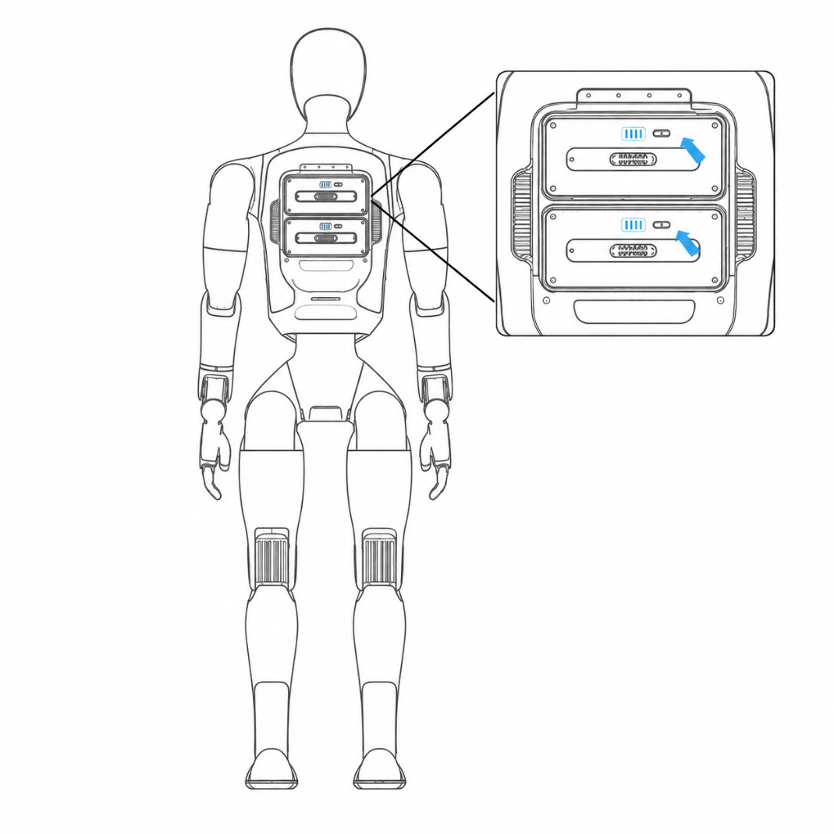

2.2.3.2 Indicator Status Description (Working)
Battery Light Status (Working) | Battery Level | Status Description
All LEDs off | 0% | No power
LED1 on, LEDs 2-4 off | 1% ≤ Battery Level < 25% | Critical Low Power (Recharge Immediately)
LEDs 1-2 on, LEDs 3-4 off | 25% ≤ Battery Level < 50% | Low Power
LEDs 1-3 on, LED4 off | 50% ≤ Battery Level < 75% | Sufficient power
LEDs 1-4 on | 75% ≤ Battery Level < 100% | Full power

2.2.3.3 Indicator Status Description (Charging)
Battery Light Status (Charging) | Battery Level | Status Description
LED1 breathing, LEDs 2-4 off | Battery Level < 25% | Critical Low Power
LED1 on, LED2 breathing, LEDs 3-4 off | 25% ≤ Battery Level < 50% | Low Power: Do not disconnect
LEDs 1-2 on, LED3 breathing, LED4 off | 50% ≤ Battery Level < 75% | Medium Power: Operable; charging to full recommended
LEDs 1-3 on, LED4 breathing | 75% ≤ Battery Level < 100% | Sufficient Power: Operable
LEDs 1-4 on | Battery Level = 100% | Charging Complete: Power can be disconnected

2.2.4 User Debugging Interfaces
No. | Hardware Expansion Interface | Interface | Description
1 | Maintenance bay: for debugging and secondary development (waist) | USB Type-A 2.0 | Supports ADU/MDU serial port reading and debugging
2 | Maintenance bay: for debugging and secondary development (waist) | Ethernet | Supports ADU debugging and secondary development
3 | Maintenance bay: power interface (waist) | USB Type-C | 5 V/3 A output; can charge external devices such as the remote controller
4 | Maintenance bay: for debugging and secondary development (head) | USB Type-C | Supports debugging and secondary development of the head HDU (RK3588s); supports connecting a microphone receiver

2.3 Robot Joint Motion Range
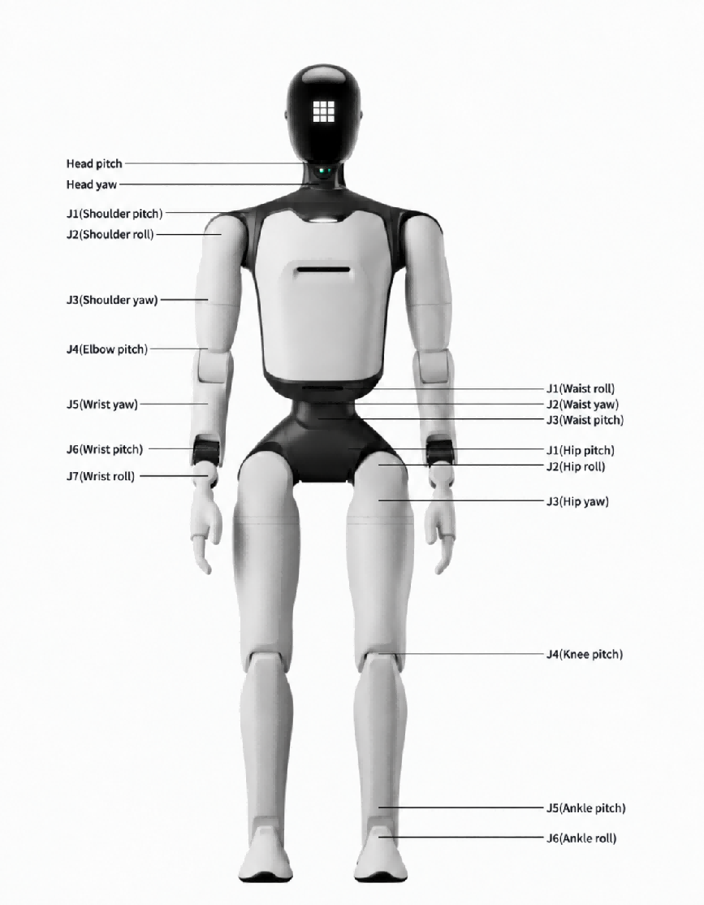
Joint Name | Joint Limit | Joint Name | Joint Limit
Arm | J1(Shoulder pitch): -165°～165° | Waist | J1(Waist roll): ±20°
 | J2(Shoulder roll): -5°~150° |  | J2(Waist yaw): ±150°
 | J3(Shoulder yaw): ±160° |  | J3(Waist pitch): -28°~24°
 | J4(Elbow pitch): -55°~100° | Leg | J1(Hip pitch): -144°~168°
 | J5(Wrist roll): ±160° |  | J2(Hip roll): -30~85°
 | J6(Wrist pitch): ±93° |  | J3(Hip yaw): ±156°
 | J7(Wrist yaw): ±93° |  | J4(Knee pitch): -7°~145°
Head | Tilt joint (Head pitch): 15° (down), 25° (up) |  | J5(Ankle pitch): -52°~30°
 | Rotation joint (Head yaw): ±60° |  | J6(Ankle roll): ±20°

Note: Joint limits are calculated based on structural design parameters. Individual differences may exist between devices, and these data are for reference only.

2.4 Robot Sensor Field of View
Robot Model | Perception Configuration | Capability
FF All-New Futurist Ultra | Interactive Binocular Camera | Supports visual recognition and response in human-robot interaction scenarios
 | Left and Right Fisheye Cameras | Surround-view environment perception, object recognition and obstacle avoidance
 | Rear-View Fisheye Camera
 | Chest RGB-D Camera | Depth and image perception of the working area
 | Hip RGB-D Camera | Depth and image perception of the ground area

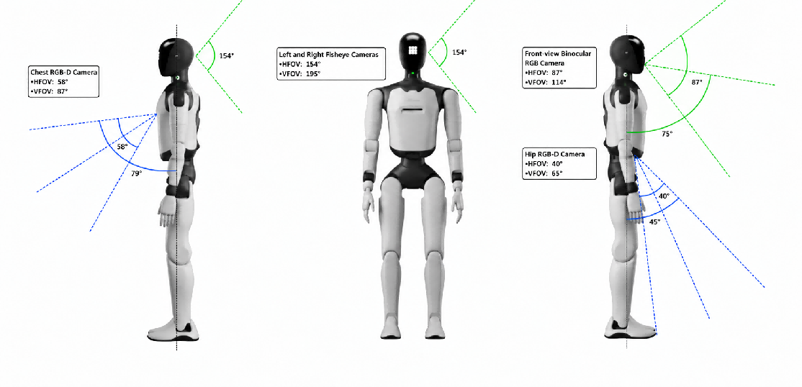

2.5 Robot Specifications
Robot Model | FF All-New Futurist Ultra
Main Body | Height | 1.74 m
 | Dimensions | 174 cm (H) x 52 cm (W) x 30 cm (L)
 | Weight | 60 KG
 | Active Degrees of Freedom | 51–71
 | Neck Degrees of Freedom | 2
 | Single Arm Degrees of Freedom | 7
 | Waist Degrees of Freedom | 3
 | Single Leg Degrees of Freedom | 6
Perception System | 3D LiDAR | Equipped
 | Embodied Operation RGB-D Camera | Equipped
 | Terrain Perception RGB-D Camera | Equipped
 | Interactive RGB Camera | RGB Binocular Camera
 | Panoramic RGB Camera | Equipped
 | GPS | Equipped
 | GPS RTK | Equipped
 | UWB Positioning | Equipped
 | Shoulder Touch Sensors | Equipped
Communication | Communication Methods | WiFi, 4G/5G Network, Bluetooth
Interaction | Microphone | Omnidirectional Microphone; Front and Rear 8-Microphone Array
 | Speaker | Equipped
 | Face Screen | Curved Screen
 | Indicator Lights | Omnidirectional Indicator Lights
Performance | Knee Joint Peak Torque | 320 N·m
 | Movement Speed | Max Daily Walking Speed: 1.8 m/s; Normal Daily Walking Speed: < 1.2 m/s; Maximum Laboratory Speed: 2.5 m/s; Max Running Speed: 5 m/s
 | Single Arm Payload | Rated 1 kg; extreme 5 kg
Operating Environment | Operating Temperature | -10°C to +45°C
Power and Energy | Battery Capacity | 1152 W·h
 | Battery Life | Total 8 h. * Actual battery life depends on usage and is affected by walking speed and load; standing / walking ratio = 1:1
 | Charging Methods | Supports direct charging, battery swapping, and autonomous charging
 | Charging Time | ≤2 h
 | Charging Input Voltage | 110-220 V
Computing Power | Basic Computing Board | RK3588 * 2
 | Advanced Computing Board | NVIDIA Thor
Others | Handheld Wireless Terminal | Equipped
 | Smart OTA Update | Equipped
 | Further Development | Supported

2.6 Radio Frequency Specifications
Wi-Fi and Bluetooth
• 2.4 GHz Wi-Fi: 20 dBm (EIRP)
• Bluetooth: 20 dBm (EIRP)
• 5 GHz Wi-Fi:
◦ 5150–5250 MHz: 23 dBm (EIRP)
◦ 5725–5850 MHz: 14 dBm (EIRP)
Wi-Fi operation in the 5150–5250 MHz frequency range is restricted to indoor use in all EU/EFTA member states and Turkey.
UWB
• 7987.2 MHz: 0 dBm (EIRP)
Cellular Bands
• LTE Band 1: Uplink: 1920–1980 MHz; Downlink: 2110–2170 MHz
• LTE Band 3: Uplink: 1710–1785 MHz; Downlink: 1805–1880 MHz
• LTE Band 7: Uplink: 2500–2570 MHz; Downlink: 2620–2690 MHz
• LTE Band 8: Uplink: 880–915 MHz; Downlink: 925–960 MHz
• LTE Band 20: Uplink: 832–862 MHz; Downlink: 791–821 MHz
• LTE Band 28: Uplink: 703–748 MHz; Downlink: 758–803 MHz
• LTE Band 32: Downlink only: 1452–1496 MHz
• LTE Band 34: Uplink and downlink: 2010–2025 MHz
• LTE Band 38: Uplink and downlink: 2570–2620 MHz
• LTE Band 40: Uplink and downlink: 2300–2400 MHz
• LTE Band 41: Uplink and downlink: 2496–2690 MHz
• LTE Band 42: Uplink and downlink: 3400–3600 MHz
• LTE Band 43: Uplink and downlink: 3600–3800 MHz
• LTE Band 46: Downlink only: 5150–5925 MHz
5G NR Bands
• NR n1: Uplink: 1920–1980 MHz; Downlink: 2110–2170 MHz
• NR n3: Uplink: 1710–1785 MHz; Downlink: 1805–1880 MHz
• NR n7: Uplink: 2500–2570 MHz; Downlink: 2620–2690 MHz
• NR n8: Uplink: 880–915 MHz; Downlink: 925–960 MHz
• NR n20: Uplink: 832–862 MHz; Downlink: 791–821 MHz
• NR n28: Uplink: 703–748 MHz; Downlink: 758–803 MHz
• NR n38: Uplink and downlink: 2570–2620 MHz
• NR n40: Uplink and downlink: 2300–2400 MHz
• NR n41: Uplink and downlink: 2496–2690 MHz
• NR n75: Downlink only: 1432–1517 MHz
• NR n76: Downlink only: 1427–1432 MHz
• NR n77: Uplink and downlink: 3300–4200 MHz
• NR n78: Uplink and downlink: 3300–3800 MHz
Maximum Transmit Power
• LTE bands: 23 dBm (+2.0/-2.0 dB)
• 5G NR Power Class 3, bands n1/n3/n7/n8/n20/n28/n38/n40: 23 dBm (+2.0/-2.0 dB)
• 5G NR Power Class 2, bands n41/n77/n78: 26 dBm (+3/-4 dB)

3. Introduction to Remote Control

3.1 Remote Control Exterior Design
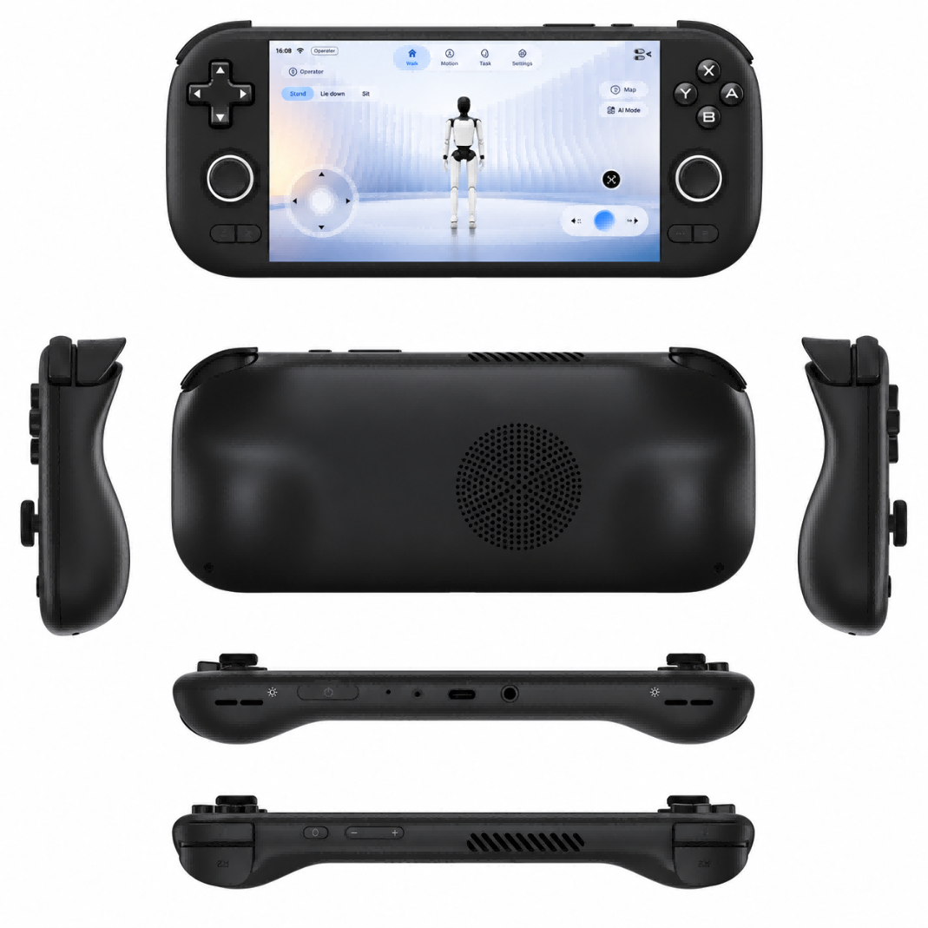

3.2 Remote Control Button Layout
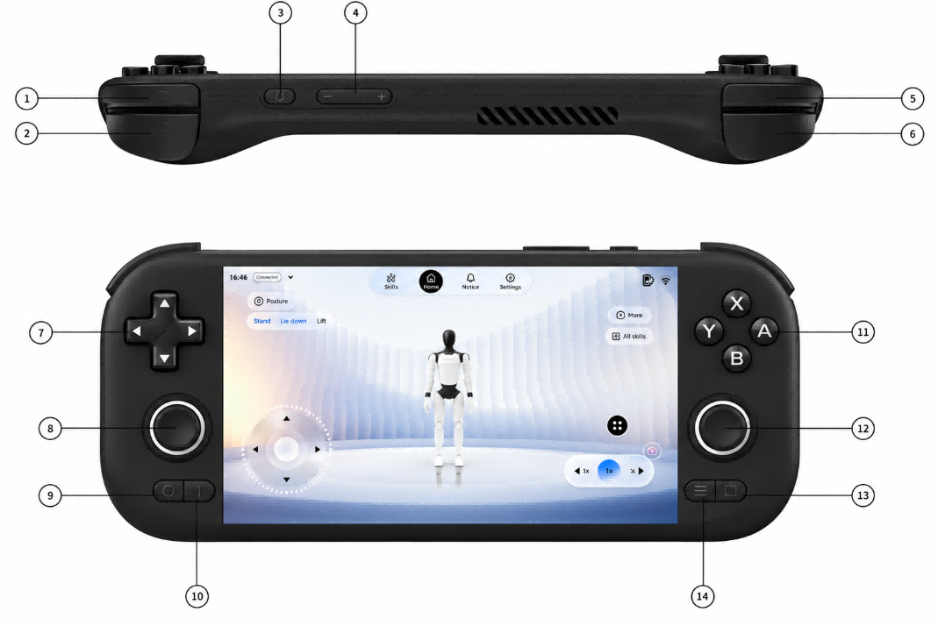
No. | Name | No. | Name
1 | Left Trigger (L2) | 8 | Left Joystick (L3)
2 | Left Shoulder Button (L1) | 9 | Back
3 | Power Button | 10 | Home
4 | Volume | 11 | A/B/X/Y
5 | Right Trigger (R2) | 12 | Right Joystick (R3)
6 | Right Shoulder Button (R1) | 13 | Start
7 | D-Pad | 14 | Select

3.3 Remote Control Charging Instructions
Charging Method: The remote control supports charging via a USB-C cable. Do not use a high-power charger, as this may degrade the remote control's performance.
Battery Life: The remote control typically lasts about 4 hours on a single charge. A full charge takes 3-4 hours. Actual battery life is affected by various factors, and the specific duration depends on actual usage.
⚠️ Precautions:
1. When using the remote control to operate the Robot, closely monitor the Robot's battery level. Low battery may prevent switching motion control modes, which could lead to the Robot falling unexpectedly.
9. Use a charger that meets safety standards to charge the remote control. It is recommended to use a 5V/1A or 5V/2A charger to prevent damage from overcharging.

4. Usage Instructions

4.1 App

4.1.1 General Guide (How to Connect the Robot)
Step 1: Language Selection (Required for First Connection)
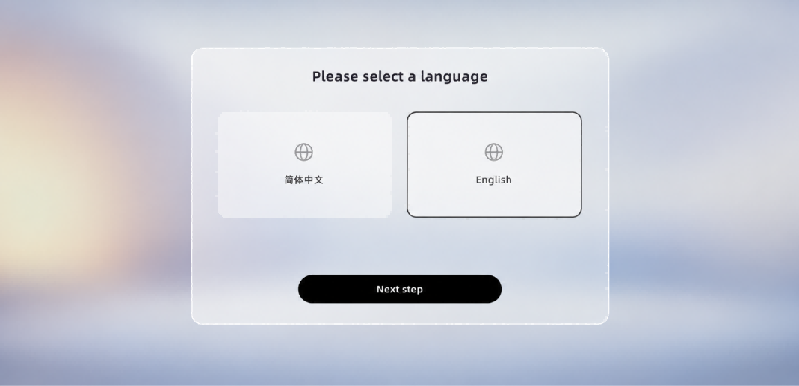
Step 2: Privacy & User Agreement (Required for the first connection)
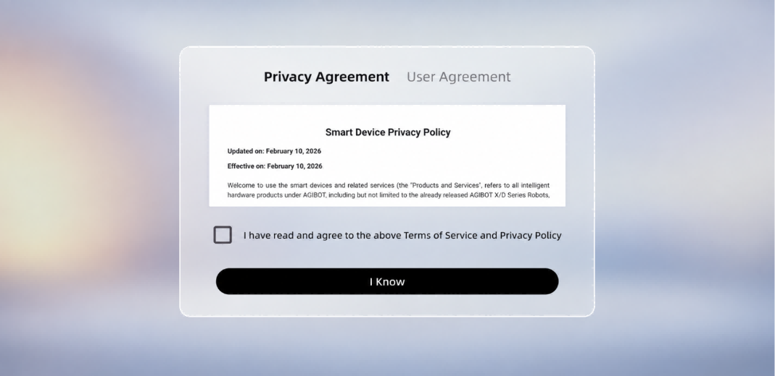
Step 3: Lock screen password setting (required for the first connection)
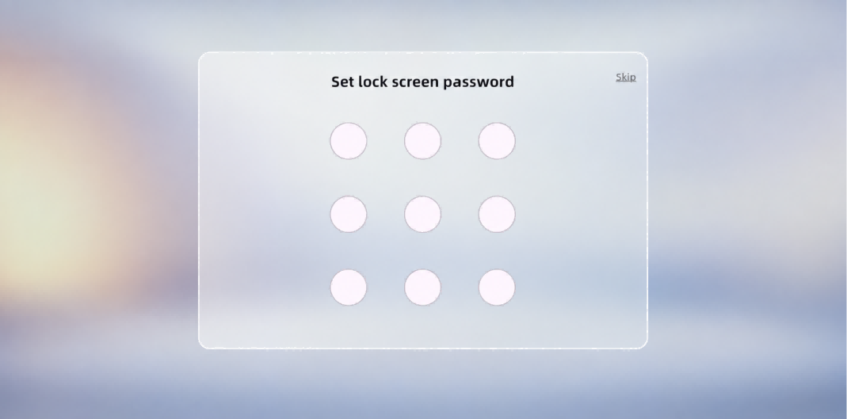
Step 4: Select the robot type
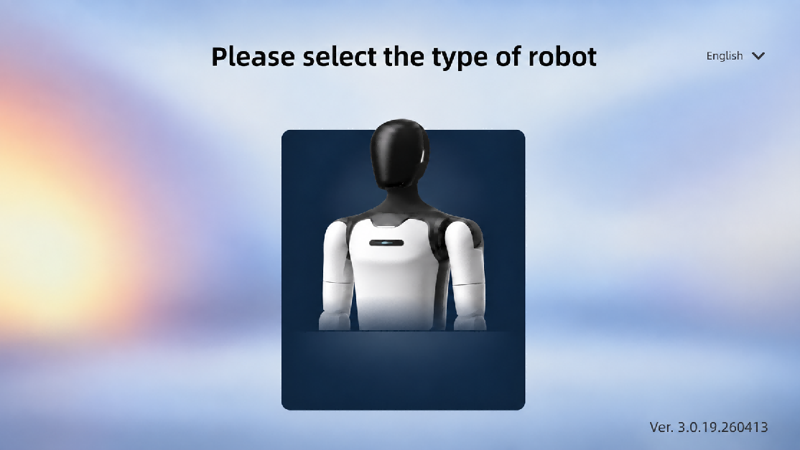
Step 5: Turn on the power
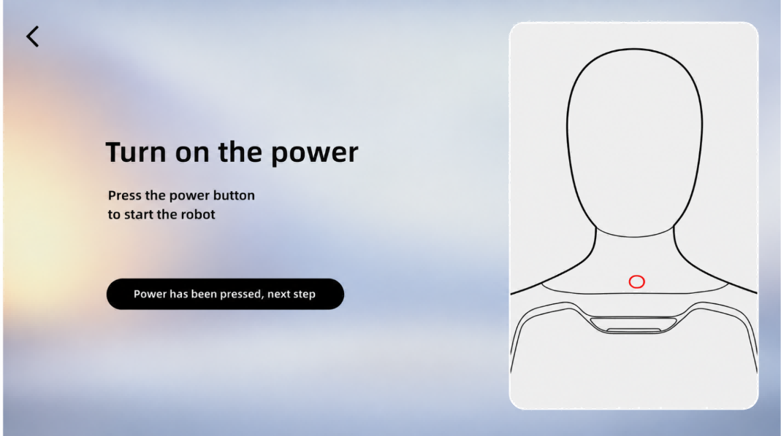
Step 6: Network connection (required for the first connection)
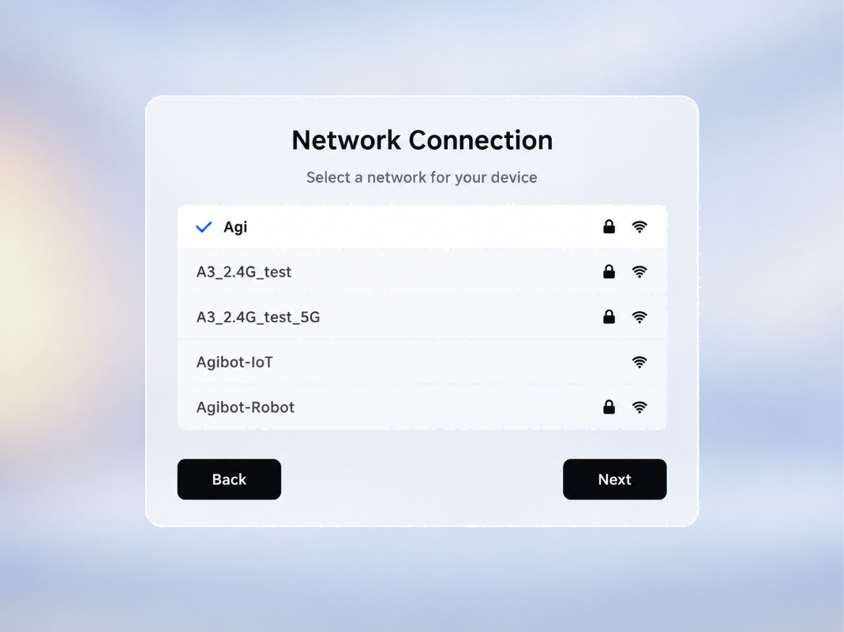
Step 7: Select the robot's language and location (required for the first connection)
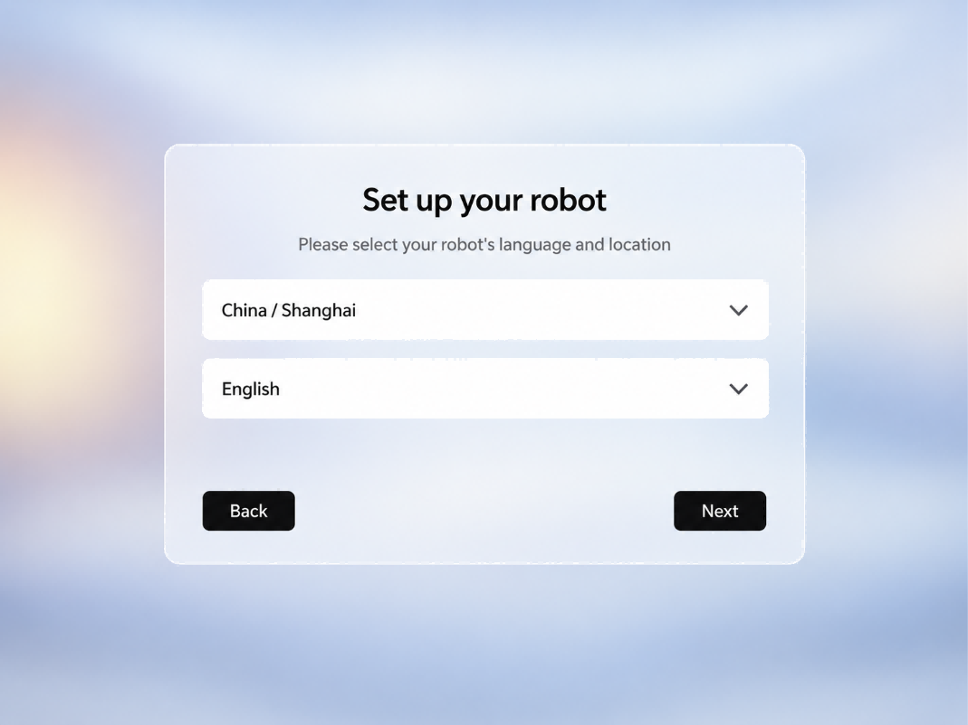
Step 8: Robot authorization password (required for the first connection)
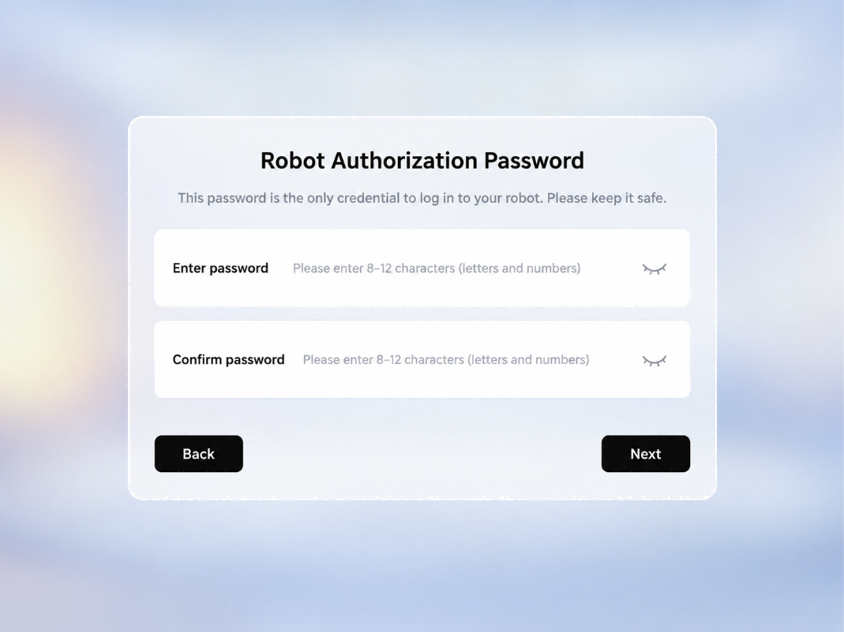
Step 9: Select the robot's posture
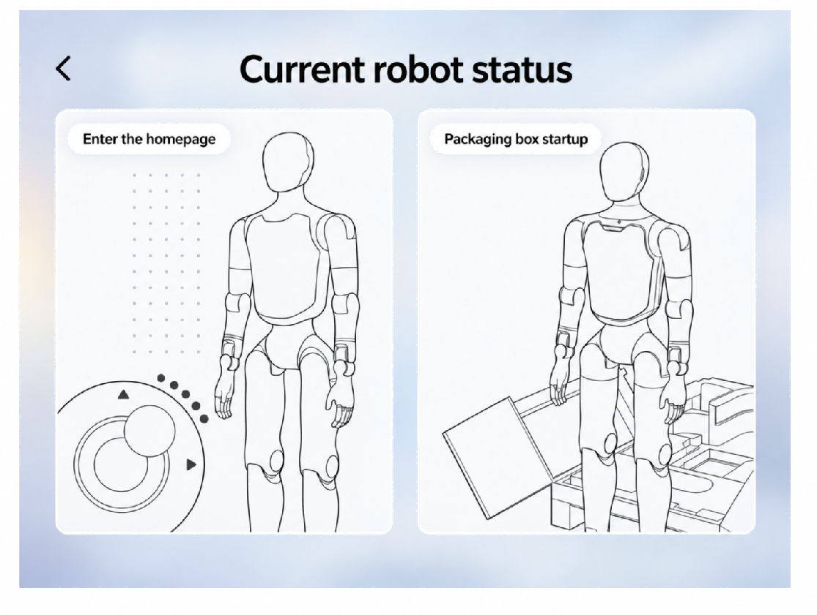
Step 10: Enter the home page

4.2 Startup Procedure

4.2.1 Packaging Box Startup
Step 1: Activate the battery
Note: This activation step is only required when opening the package for the first time or when the battery pack is in storage and transportation mode.
Stand the packaging box upright, open the bottom window, then short press and long press (1s) the power button of each of the two battery packs, until all the indicator lights of the battery packs light up in sequence, indicating successful activation. Then close the bottom window.
Step 1-1: Stand up the packing box and open the bottom window  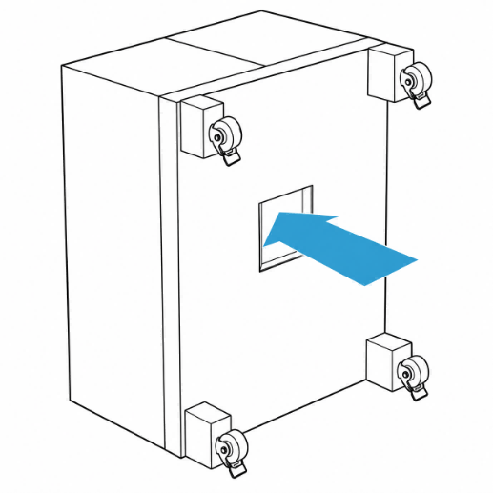 | Step 1-2: Activate two battery packs  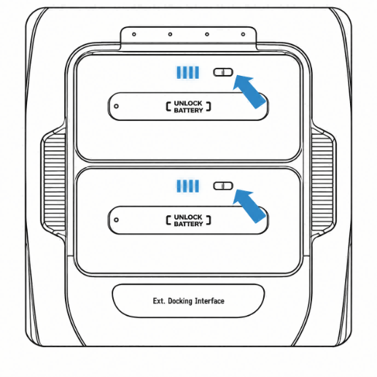

Step 2: Open the package
Lay the packing box flat, lock the wheels at the bottom of the packing box after confirming that there are no obstacles in front, then open the top cover of the packing box and remove the middle layer and hip-cover foam, ensuring that there are no items above the robot.
Step 2-1: Place the packing box flat  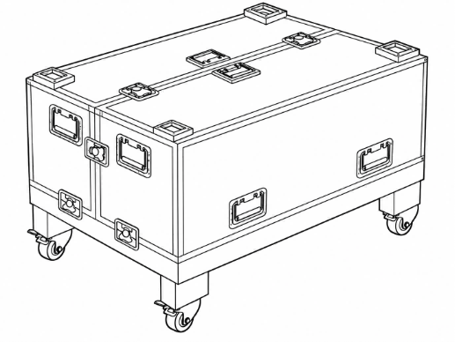 | Step 2-2: Lock the wheels at the bottom of the packing box  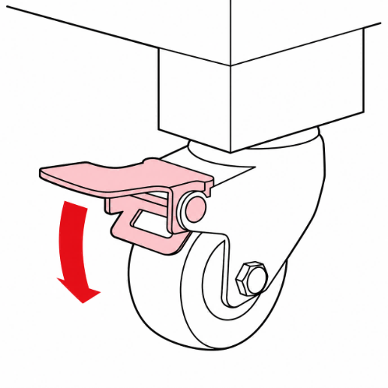

Step 2-3: Unlock and open the top cover of the packaging box  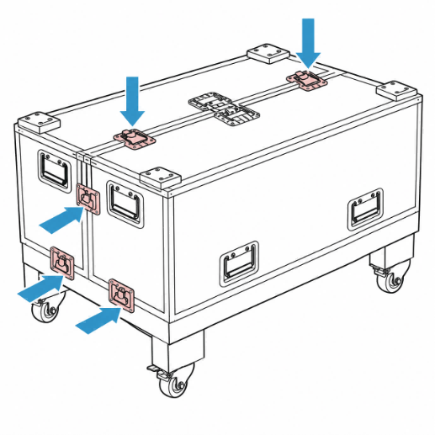 | Step 2-4: Remove the middle layer and hip-cover foam  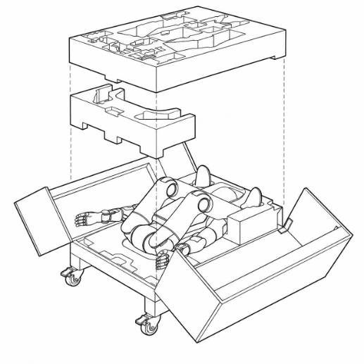

Step 3: Power on and start
Press and hold the robot's power button to turn on the robot. After the robot is powered on, the head screen and the indicator light on the chest will light up.
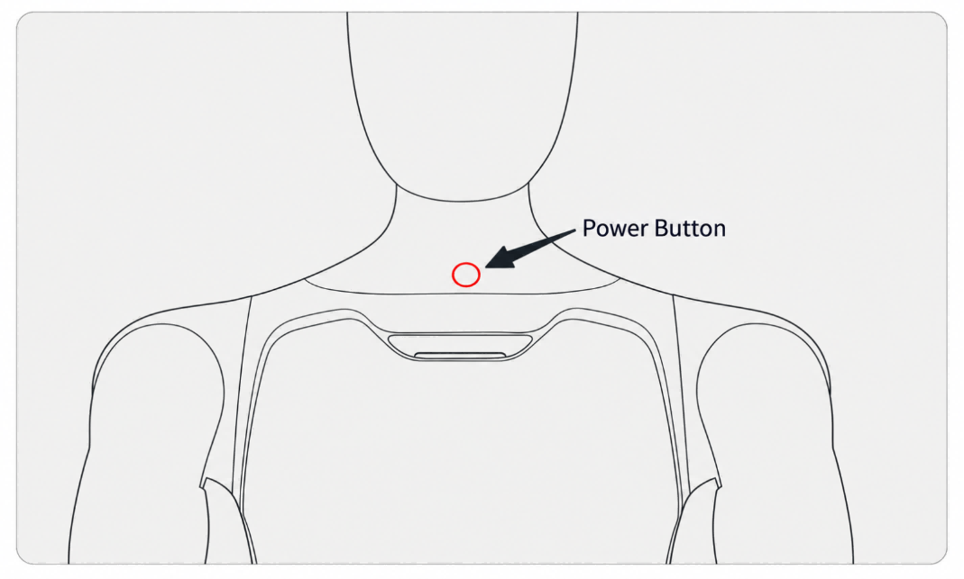
Step 4: Connect to the App
Complete the connection between the App and the robot according to the steps in Section 4.1, and select the [Packaging Box Startup] card on the [Please Select Robot Posture] page.
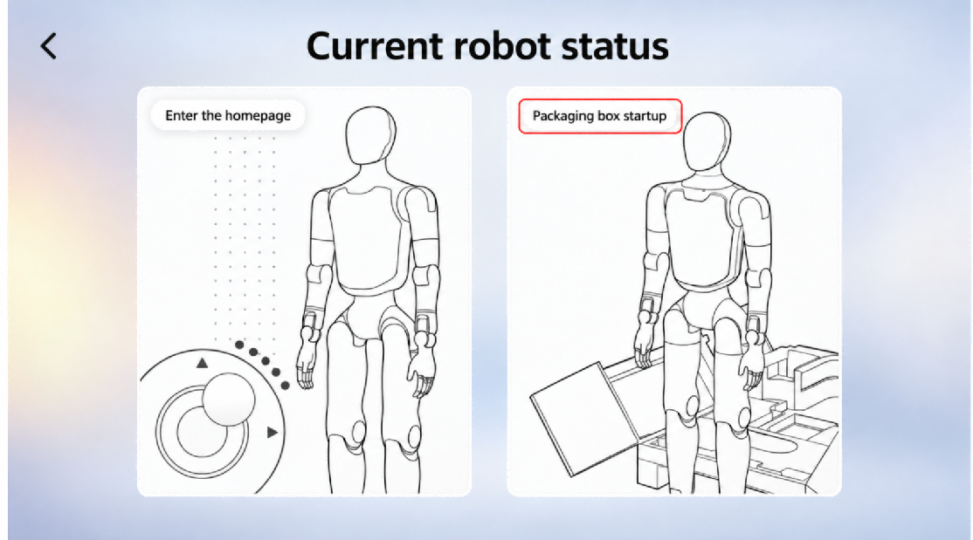
Step 5: Stand up inside the box
After confirming the environment step by step in the App, control the robot to stand up from the box with one click. The robot will then enter the motion state and maintain a stable standing posture.
⚠️ Note: Observe the following:
• Ensure no obstacles are present in front of the packaging box.
• Lock all casters of the box securely.
• Make sure the robot's hip position is above the red line; adjust it manually above the red line if not.
• Do not touch the robot during the stand-up process.
• After the robot stands up, move the packaging box at least 0.5 meters away before operation.

Operation Steps | Operation Interface
Ensure the packaging box is placed steadily with no obstacles ahead | 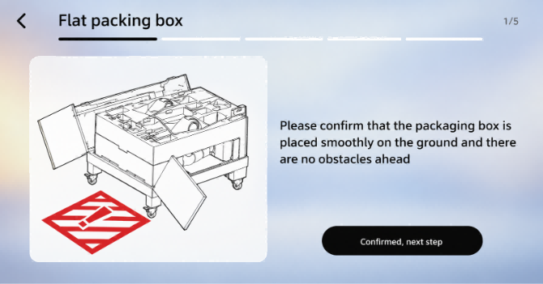
Confirm the box casters are locked | 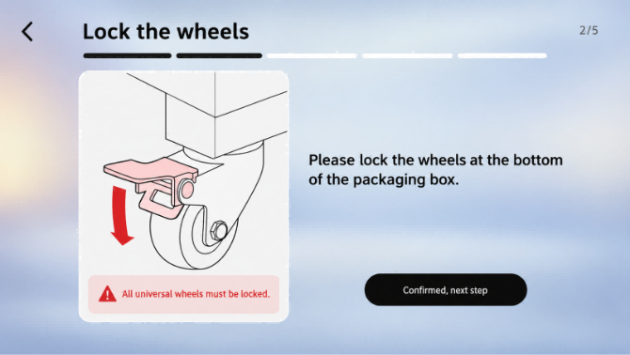
Confirm the middle layer and hip-cover foam is removed | 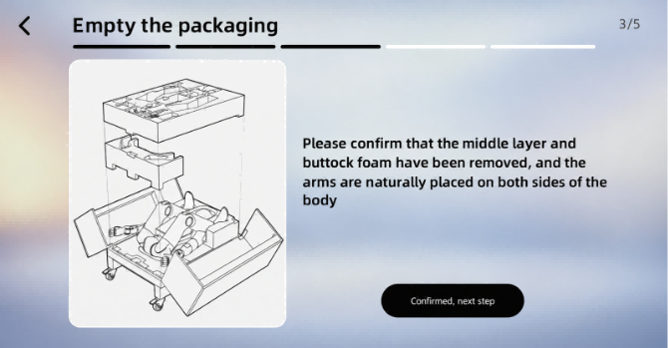
Confirm that the robot's position is correct | 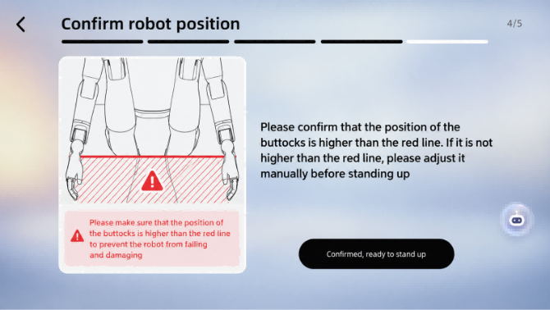
Confirm initiating the robot stand-up | 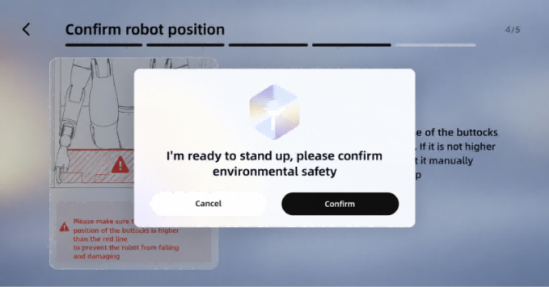
Robot standing up (automatic) | 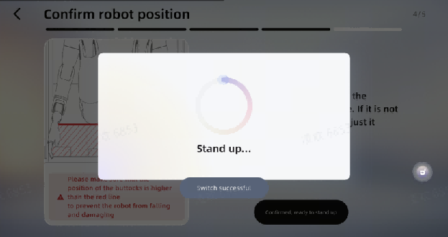
The robot successfully stands up, moves the packing box away, and ready to use | 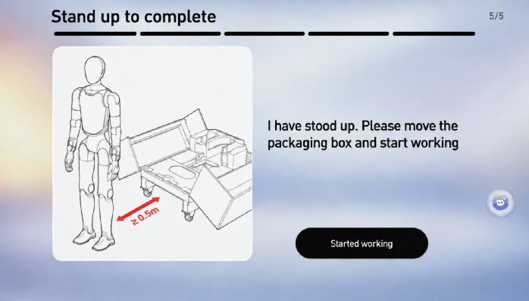

4.2.2 Power On in Supine Position
Step 1: Power on and start
Press and hold the robot's power button to turn on the robot. After the robot is powered on, the head screen and the indicator light on the chest will light up.
⚠️ Note: If the battery pack is in storage and transportation mode, it is necessary to activate the battery pack before powering on. The operation method is to short press and then long press (1s) the power button on the battery pack, until all the battery pack indicator lights light up sequentially.

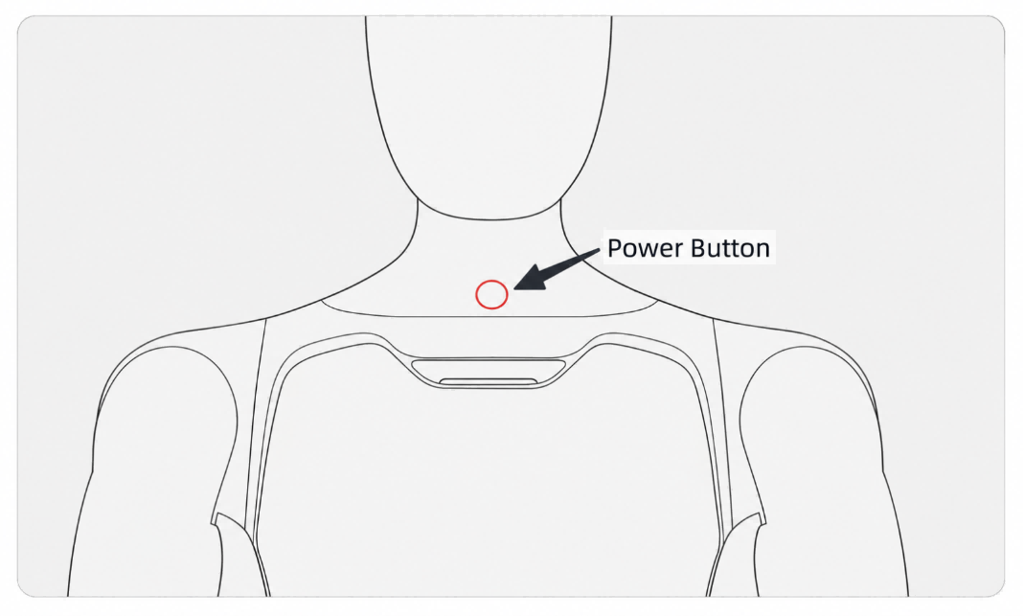
Step 2: Lay the robot flat
Lay down the robot on a flat surface as shown in the following illustration, ensuring that the entire body of the robot faces upward, its limbs are extended, and its arms are naturally placed on both sides of the body.
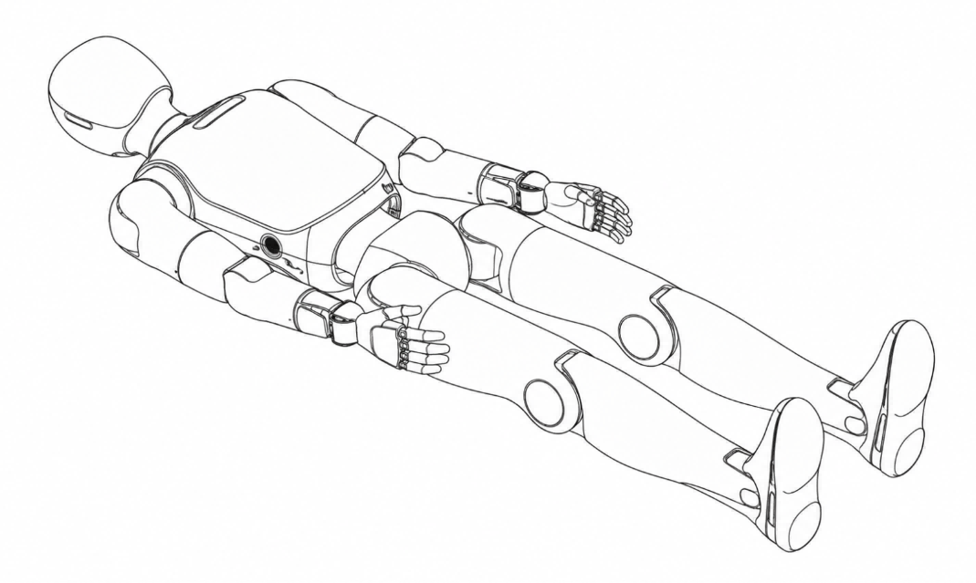
Step 3: Connect to the App
Complete the connection between the App and the robot according to the steps in Section 4.1, and select the homepage entering option on the robot status page.
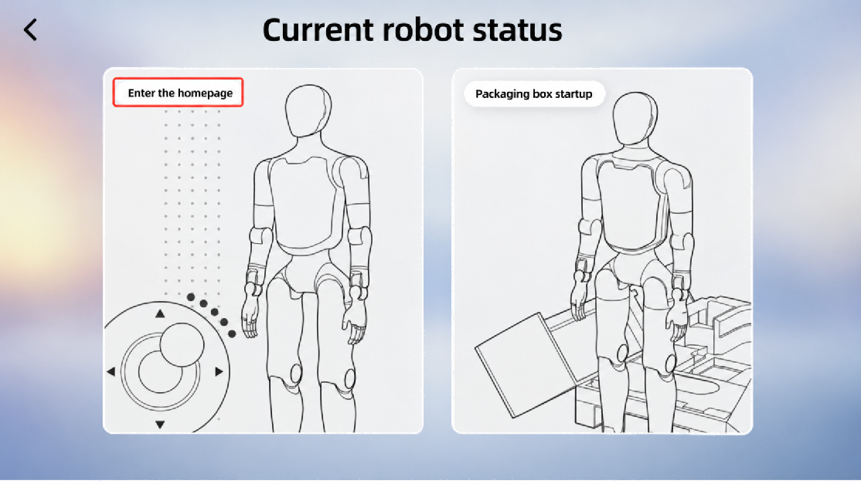
Step 4: Confirm environmental safety
Before triggering the lying-down-to-standing-up action, it is necessary to ensure that there are no foreign objects within a 1-meter radius around the robot to reserve sufficient safety space for the action execution.
Step 5: Stand up from lying flat
Under the Posture switch on the home page of the App, choose "Stand" to enable the robot to stand up from a lying position. At this time, the robot enters a motion state and stands stably.
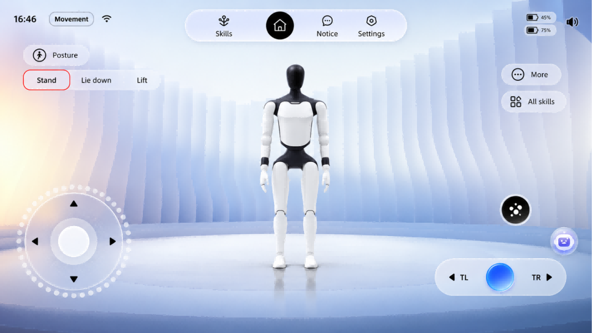

4.2.3 Power On in Prone Position
Step 1: Power on and start
Press and hold the robot's power button to turn on the robot. After the robot is powered on, the head screen and the indicator light on the chest will light up.
⚠️ Note: If the battery pack is in storage and transportation mode, it is necessary to activate the battery pack before powering on. The operation method is to short press and then long press (1s) the power button on the battery pack, until all the battery pack indicator lights light up sequentially.

Step 2: Lay the robot face-down
Lay the robot face-down on a flat surface as shown in the illustration, ensuring that the entire body of the robot faces downward, its limbs are extended, and its arms are naturally positioned on both sides of the body.
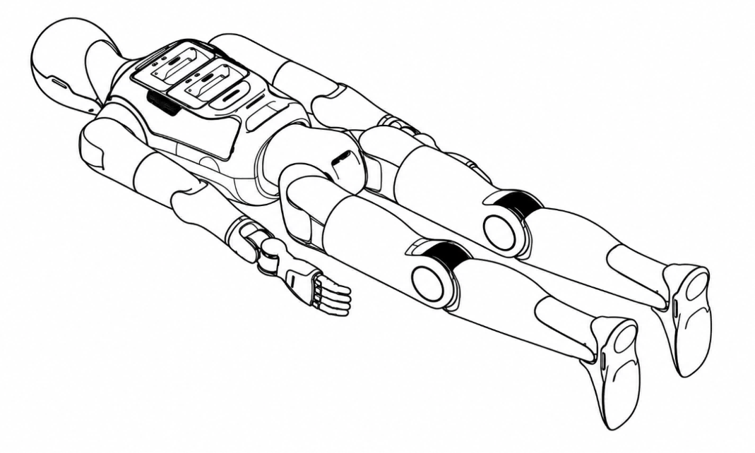
Step 3: Connect to the App
Complete the connection between the App and the robot according to the steps in Section 4.1, and select the homepage entering option on the robot status page.
Step 4: Confirm environmental safety
Before triggering the prone-to-standing action, it is necessary to ensure that there are no foreign objects within a 1-meter radius around the robot to reserve sufficient safety space for the action execution.
Step 5: Stand up from a prone position
Under the Posture switch on the home page of the App, choose "Stand" to enable the robot to stand up from a lying position. At this time, the robot enters a motion state and stands stably.

4.3 Shutdown Procedure

4.3.1 Shutdown and Packing
⚠️ Note: Observe the following:
• When moving the packing box to align with the robot, be sure not to hit the robot.
• Before the robot enters the packaging, confirm that all casters have been locked.
• Do not touch the robot during the return-to-box process.
• After shutdown, wait until the chest indicator light goes off (about 20 s).
• In case of a fault, press and hold the power button for 30 s to force shutdown.

Step 1: The robot is in motion and standing stably
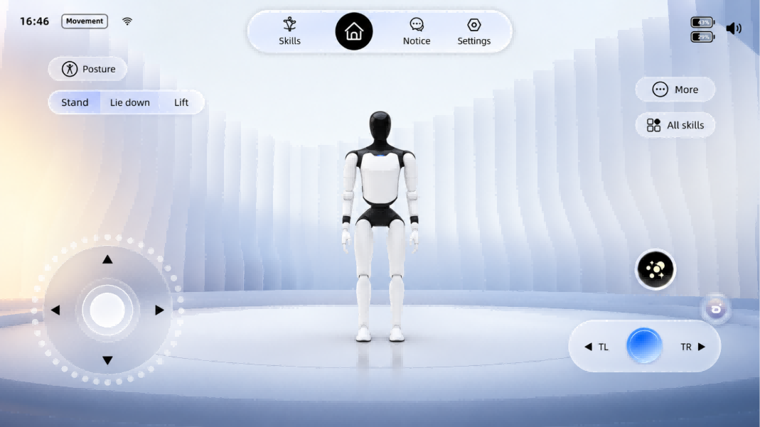
Step 2: Initiate the self-service return process
On the <Settings> - <Packing> page of the App, choose <Autonomous return to Box>, and start the return-to-box process after ensuring the surface is level.
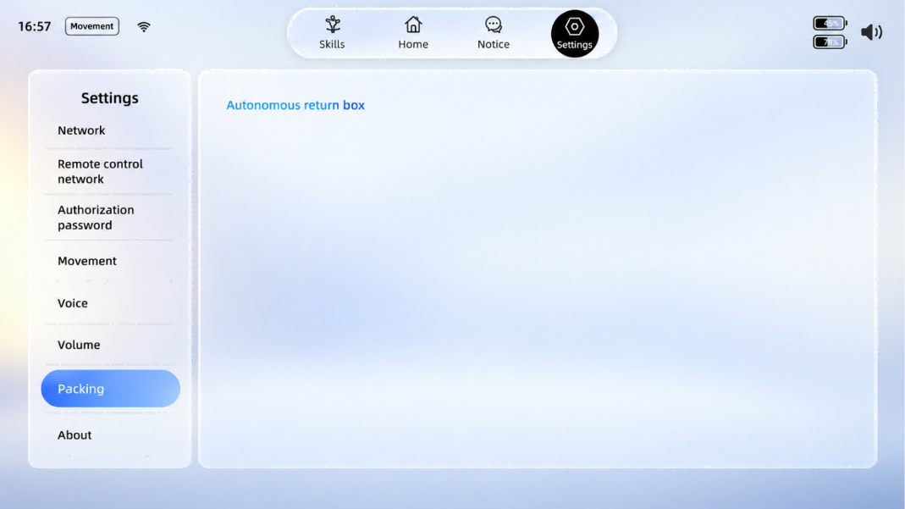
Step 3: Move and position the packaging box
Pull out the positioning block from inside the packing box, turn it over to the outer wall of the packing box and press it firmly against the wall; move the packing box to the back of the robot so that the positioning block gently touches both legs and centers itself for positioning.
Step 3-1: Flip out the positioning block  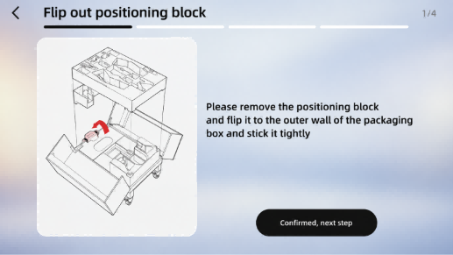 | Step 3-2: Align the robot  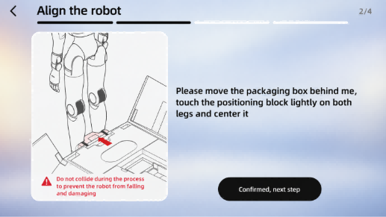

Step 4: Lock the packing box
Lock all the casters of the packing box, and confirm that the inside of the packing box has been cleaned up.
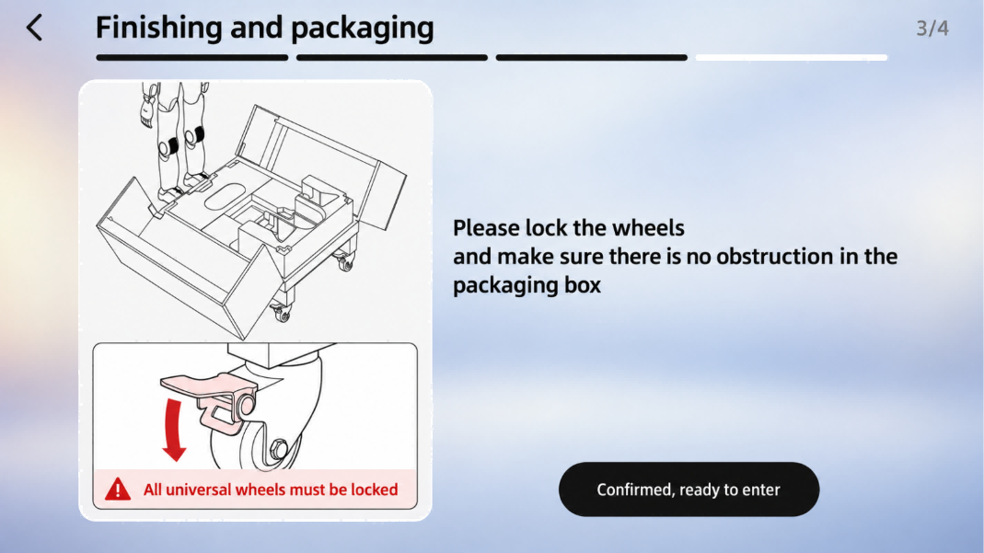
Step 5: Robot returns to the box
After confirming environmental safety, confirm to start entering the packaging box.
Step 6: Shut down and pack
After the robot is placed inside the packaging box, briefly press the power button on the chest, and follow the voice prompts to turn it off; then insert the positioning block, hip-cover foam, and middle layer foam back into their original positions to secure and protect the robot; finally, close the packaging box and lock it.

4.3.2 Shutdown with Supine Position
⚠️ Caution: Ensure a 1-meter radius safety space around the robot to avoid collisions.

Step 1: The robot is in motion mode, use the remote control to connect to the robot
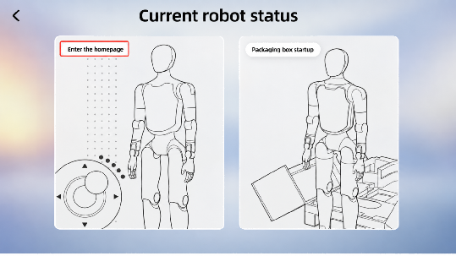 | 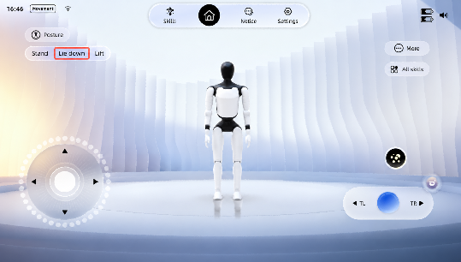

Step 2: Remote control the robot to lie flat
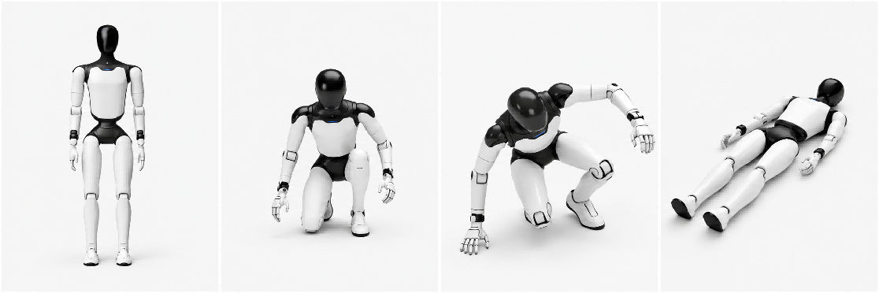
Step 3: Short press the power button on the chest, and follow the voice prompts to turn off the device
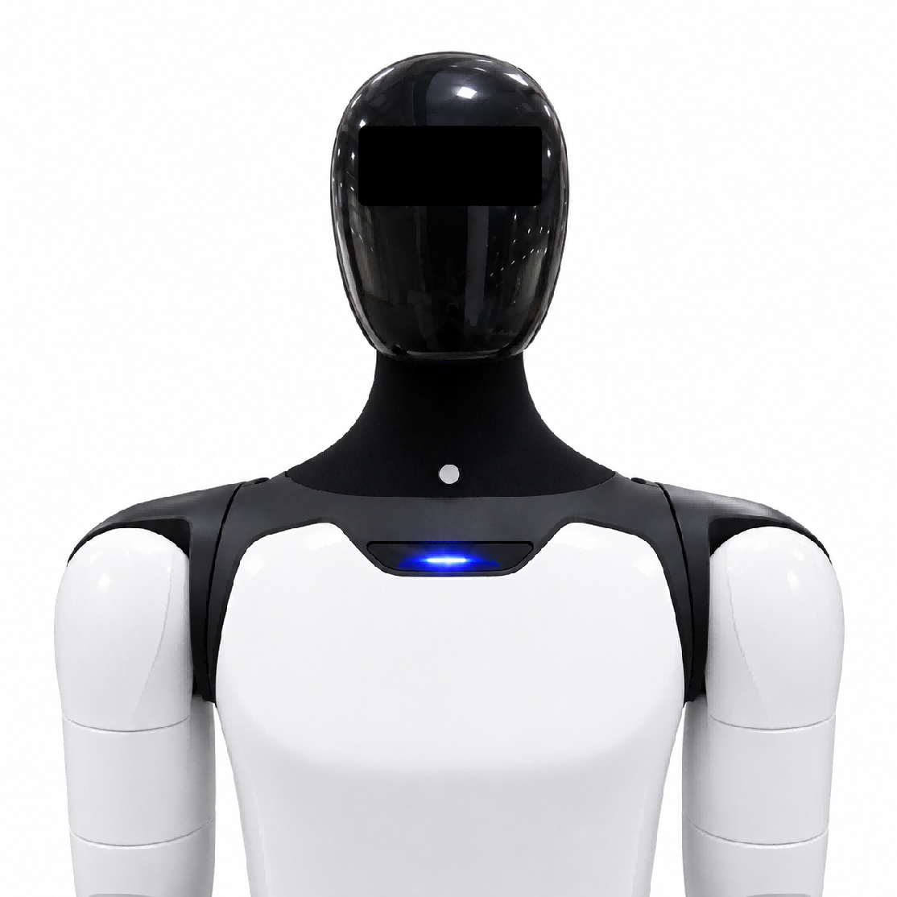

4.4 Entering and Exiting Battery Pack Storage Mode
⚠️ Note: Before transportation or long-term storage, it is recommended to enable the battery pack storage mode. If the robot is powered off without entering Storage Mode, the system will still consume approximately 7W of standby power, and a fully charged battery pack may be completely depleted in about 7 days.

4.4.1 Enter Storage Mode
Step 1: Press the battery pack power button briefly 5 times continuously. After the red indicator starts flashing, press and hold the power button.
Step 2: Continue holding the button until the green indicator starts flashing, then release the button. The battery pack has now entered Storage Mode.
Storage Mode Activation Check:
Briefly press the battery pack power button once. If the battery indicator lights up only after a few seconds, Storage Mode has been successfully activated.

4.4.2 Exit Storage Mode
Step 1: Briefly press the battery pack power button once to make all green indicators light up, and perform the Storage Mode check.
Step 2: Immediately press and hold the power button again. When the indicator light sequence completes, the battery pack has been successfully activated and has exited Storage Mode.

4.5 Charging and Battery Changing

4.5.1 Charging Mode
1. Charging the robot with battery installed
When both batteries are in place, the magnetic charging head of the charger can be connected to the charging port of the robot. After the power is turned on, the magnetic charging head of the charger lights up green, indicating successful charging. The schematic diagram is as follows:
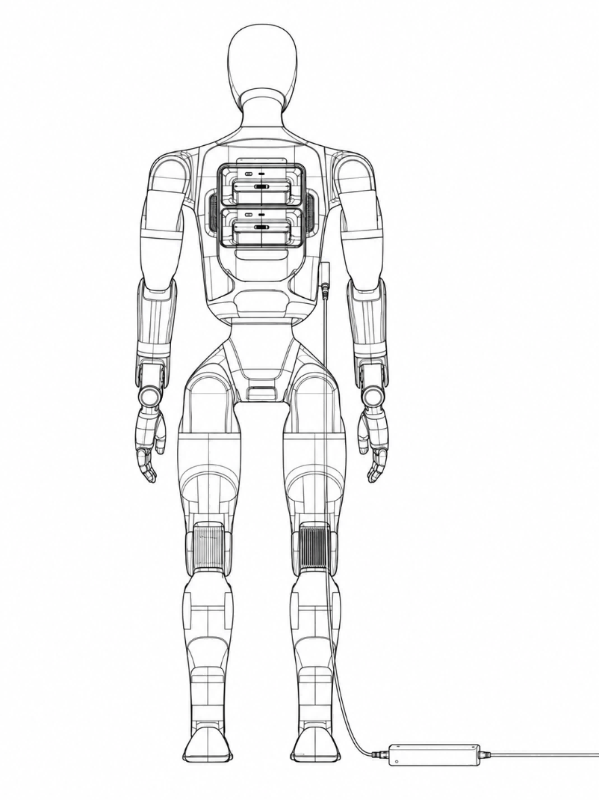
2. Charging the battery solely
Remove the battery and separate the magnetic adapter section of the charger to directly charge the battery. The schematic diagram is as follows:
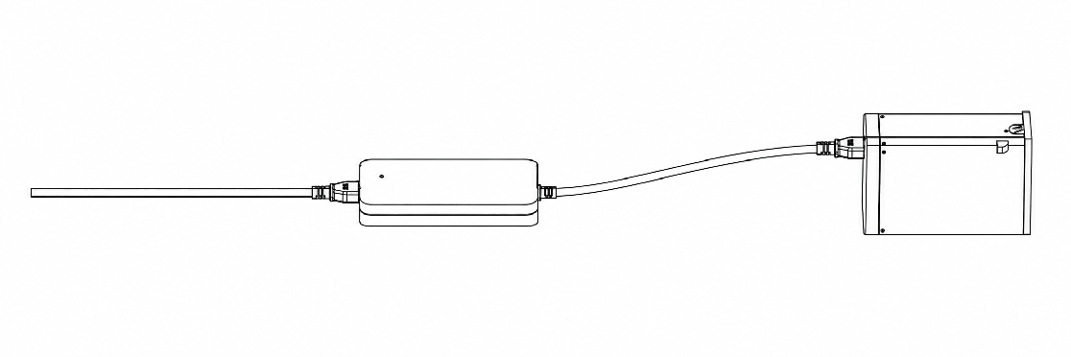

4.5.2 Battery Changing Mode
⚠️ Note: If the battery pack is in storage and transportation mode, it is necessary to activate the battery pack before powering on. The operation method is to short press and then long press (1s) the battery pack power button until all the battery pack indicator lights light up sequentially.

Step 1: Remove an individual battery
Step 2: Insert the "new" battery
Step 3: Repeat the above actions and replace the second battery
* An individual battery can be removed in both the shutdown state and the powered-on standing state (when only a single battery is left in place, the robot is restricted from moving).
⚠️ Note: If the battery pack is in storage and transportation mode, it is necessary to activate the battery pack before powering on. The operation method is to short press and then long press (1s) the battery pack power button until all the battery pack indicator lights light up sequentially.

4.5.3 Autonomous Charging

4.5.3.1 Functional Overview
🦄 • Autonomous charging is a prerequisite for the robot to achieve 7 x 24-hour autonomous operation.
• When the robot needs recharging, it autonomously navigates to the charging point and completes actions such as identifying and plugging in the charging gun to start charging; after charging is complete, it autonomously performs the wrap-up actions — unplugging, holstering the gun, and retracting the arm — and ends charging on its own.

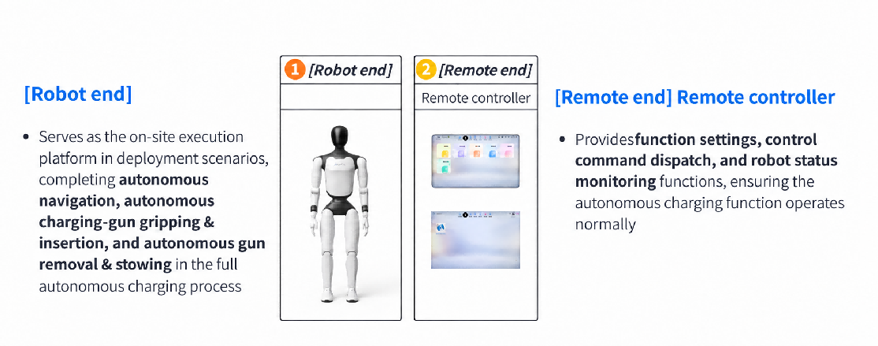
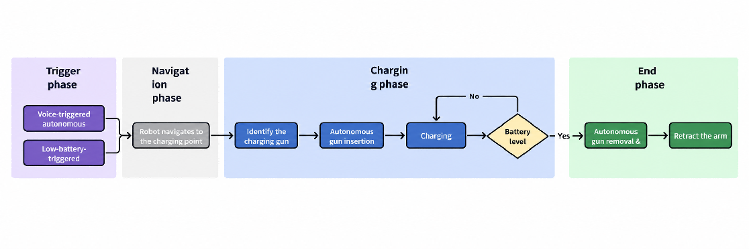

4.5.3.2 Preparation
Prerequisites: Complete mapping first, and make sure the robot is in motion mode and has been localized on the current map. This section covers the autonomous charging function only; for mapping, navigation, and relocalization, refer to the corresponding user manuals.

4.5.3.2.1 Deploying the Charging Point
1. Fix the charging gun base to the edge of a light-colored table with the fixing clip (deployment on dark-colored tables is not supported in this release); table height: 75–95 cm. Connect the other end to a power supply.
2. Attach the charging point marker board in the orientation shown: align its bottom edge with the table edge and press its right edge tightly against the charging gun base; peel off the protective film on the back and stick it to the desktop.
3. Remote-control the robot to the table where the charging gun is fixed.
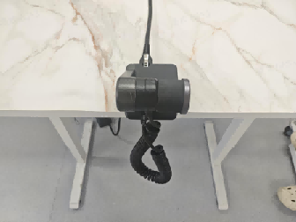  Secure the charging connector to the edge of the table | 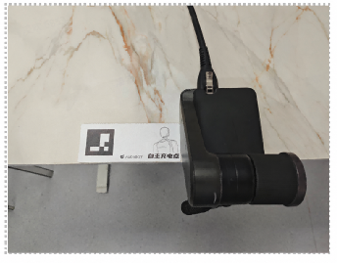  Attach the charging-point marker | 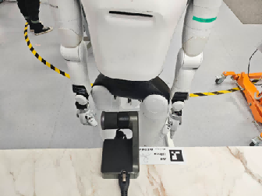  Use the remote controller to move the robot next to the table.

4. Open the App map page and select Edit Map.
5. Select Point → Record → Charging Point in turn. The live feed from the robot's chest camera appears in the upper-left corner, and the dashed box in the lower-right corner indicates the best deployment position for the charging gun.
6. Fine-tune the robot's position with the controller or by dragging until the charging gun is inside the dashed box; the dashed box turns green once the charging gun is detected.
7. Tap Charging Point → Mark, name the charging point, and tap Save to finish creating it.
◦ Note: The charging point can be given a custom name; this does not affect how the function is triggered.
8. Only one charging point can be created per map. To change the charging point location, delete the current charging point first and then create a new one.

4.5.3.2.2 Enabling Autonomous Charging
1. Autonomous charging can be enabled on the Settings → Map page.
2. Two trigger methods are available: voice trigger and low-battery trigger.
◦ With voice trigger enabled, autonomous charging can be triggered by the voice command.
◦ For the low-battery trigger, you can choose a threshold of 20%, 30%, 40%, or 50%; autonomous charging is triggered when the battery level falls below the selected threshold.
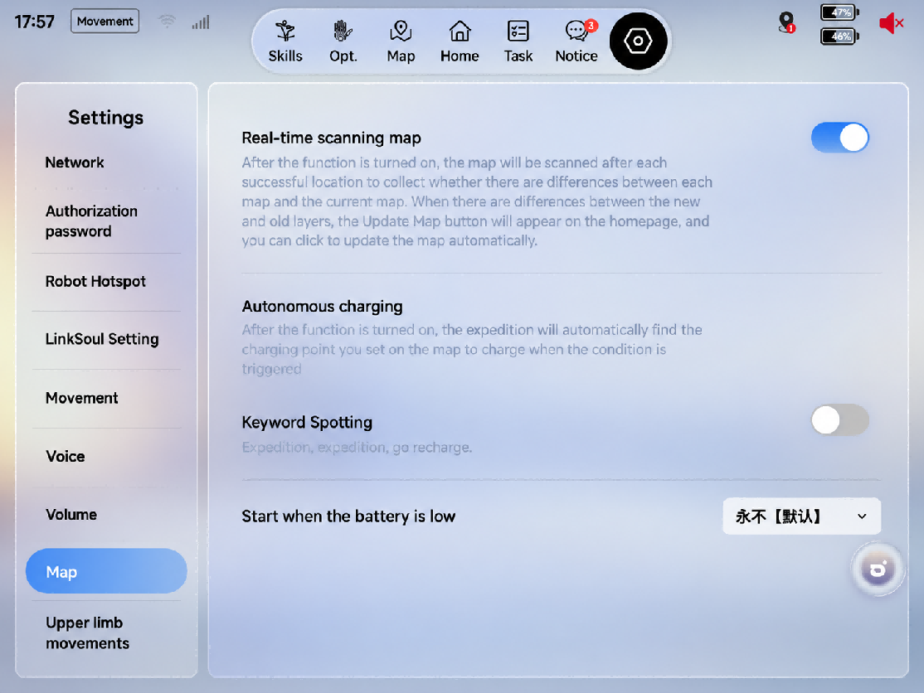

4.5.3.3 Autonomous Charging

4.5.3.3.1 Starting Autonomous Charging
Preconditions for normal triggering: The robot is not executing any task other than Lively Standby; a charging point exists on the current map; the robot's localization is normal and the robot is in a movable state.

Trigger Method | User Operation
Voice trigger | Say "[Wake Word], go charge" or "[Wake Word], go to the charging point"
Automatic low-battery trigger | Triggered automatically when the battery level falls below the configured threshold

4.5.3.3.2 Ending Autonomous Charging
Exit Method | User Operation
Voice exit | Say "[Wake Word], end charging" or "[Wake Word], stop charging"
Manual exit from the client | Tap End Charging Task in the client
Full-battery exit | No operation needed; triggered automatically when the battery level exceeds 95%

4.5.3.3.3 Interrupting Autonomous Charging
Condition for ending autonomous charging: Both batteries are correctly installed and the battery level is ≥ 15%. Otherwise, the robot cannot exit charging autonomously.

Phase | Can Be Interrupted | How to Interrupt
Navigation | Yes | Voice command; terminate the task in the client
Plugging in the gun | No | Not supported
Charging | Yes | Voice command; terminate the task in the client
Unplugging the gun | No | Not supported

4.5.3.4 Troubleshooting Quick Reference
Symptom | Possible Cause | Solution
Autonomous charging cannot be triggered | Trigger method not enabled; no charging point set (or wrong charging point name); localization abnormal; robot not movable; or another task in progress | Check the settings, map localization, and robot status; trigger again after other tasks finish
Cannot reach the charging point | Path blocked by people, objects, or temporary obstacles | Clear the path, exit the current task in the client, and trigger autonomous charging again
Charging gun not recognized | Charging gun in the wrong position, outside the dashed box, occluded, or abnormal lighting | Adjust the charging gun position; make sure it is unobstructed and lighting is normal
Plugging, unplugging, or holstering the gun fails | Charging gun position offset; QR code position offset; arm path blocked; cable under tension | Do not forcibly pull the arm or cables; wait until the robot's arms return to its sides, then manually help the robot plug in, unplug, or holster the gun

4.5.3.5 Precautions
⚠️ Precautions
1. Before triggering autonomous charging, make sure both batteries are correctly installed and the battery level is at least 5%. Otherwise, insufficient power may prevent the robot from completing the charging process or cause it to fall.
2. If the robot is in an abnormal state, emergency-stop state, or abnormal posture, restore the robot to a normal state before triggering autonomous charging.
3. Do not move the deployed charging table, charging gun, or charging base at will. If their positions change, check and update the charging point again.
4. During autonomous charging, do not cover the QR code on the table, as this affects recognition and plug/unplug success rate.
5. During autonomous charging, do not cover the robot's cameras, the charging gun, or the charging base, as this affects recognition and plug/unplug success rate.
6. Do not reach in while the robot is plugging in / unplugging the gun. If the operation fails, wait until the robot's arms return to its sides before attempting to recover.
7. If the robot fails to plug in the gun autonomously, manual assistance is required. After manually assisting the plug-in, the robot cannot exit this charging task autonomously.
8. After each charging task, make sure the charging gun is correctly returned to the base. If the robot fails to holster it, return it manually; otherwise the next autonomous charging task cannot start.
9. The entire autonomous charging process cannot be interrupted by other tasks. Do not launch other tasks while autonomous charging is running.

4.6 Emergency Stop Function
The emergency stop function is used for the emergency stop of the robot in case of sudden situations, preventing further damage to the robot or the surrounding environment, and can be triggered in the "Soft Emergency Stop" mode.
After the robot enters the emergency stop state, its limbs will lose power and fall to the ground, with a certain risk of damaging the machine. Please ensure that users use the emergency stop function with extreme caution.

4.6.1 Triggering the Soft Emergency Stop
1. Steps to trigger the emergency stop state
Method 1: Triggered via the App
Operation Steps | Operation Interface
Press the floating ball to enter the emergency stop page | 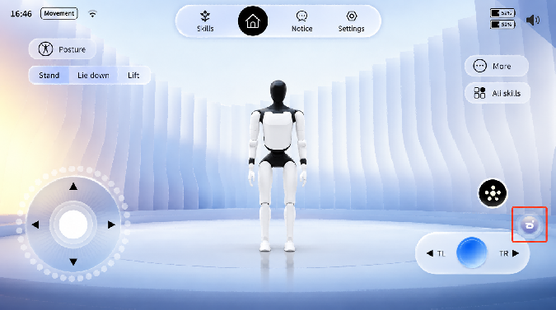
Press and hold the [Emergency Stop] button, then slide it to the right until it reaches the end to trigger a soft emergency stop | 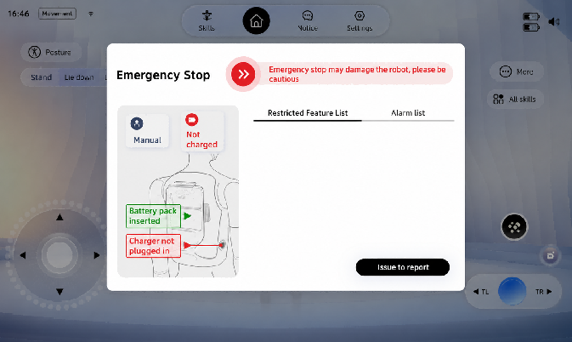
Enter the soft emergency stop state | 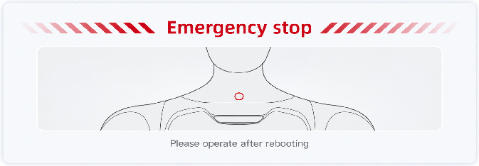

Method 2: Triggered by remote control buttons (applicable to remote controls)
When the remote control is connected to the robot, hold the four buttons L1+L2+R1+R2 at the same time for more than 0.5 seconds to trigger the soft emergency stop state.
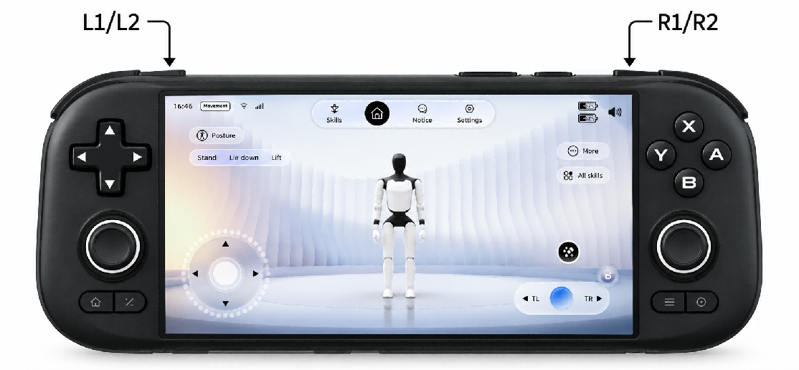
2. Operable items in the soft emergency stop state
After the robot enters the soft emergency stop state, only limited operations such as viewing the function list and alarm information, and reporting problems, can be performed on the floating ball page.
Operation Steps | Operation Interface
Tap the floating ball
Limited operations such as viewing the function list and alarm information, and reporting problems, can be performed

3. Steps to exit the soft emergency stop state
Restart the robot to exit the soft emergency stop state.
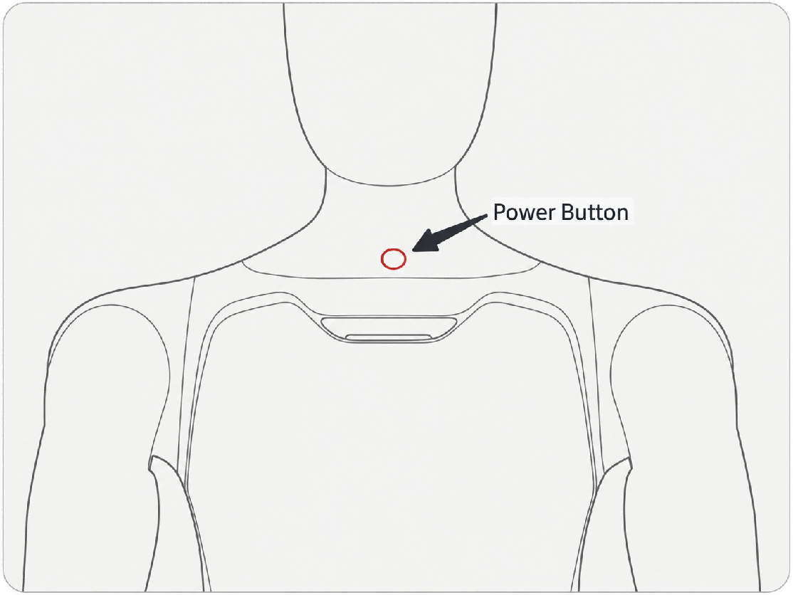

4.6.2 Emergency Stop Settings
Turn on/off the soft emergency stop function: On the [Settings] - [Movement] page of the App, you can turn the software emergency stop function on and off.
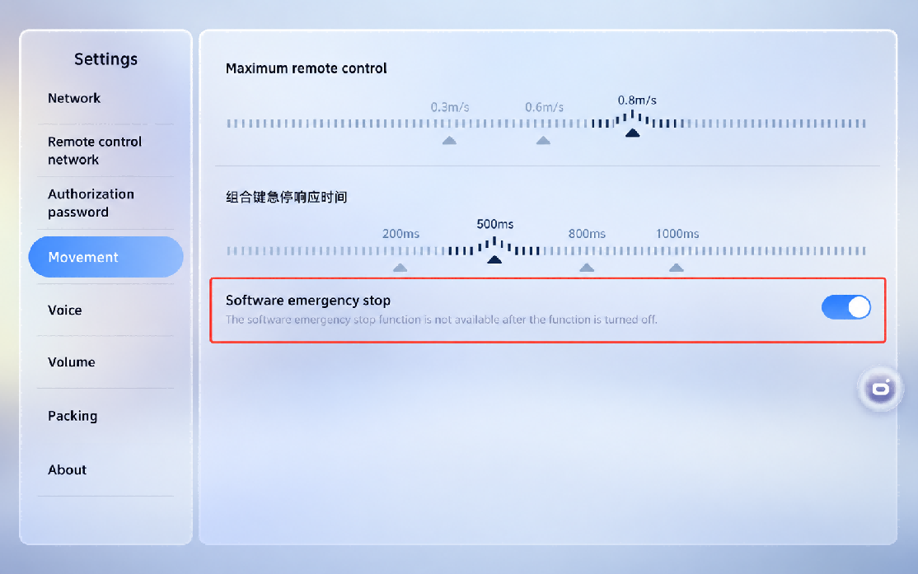

4.7 Lifting Ring Installation
• Step 1: Pull out the rubber plugs on both shoulders of the robot to expose the mounting slot
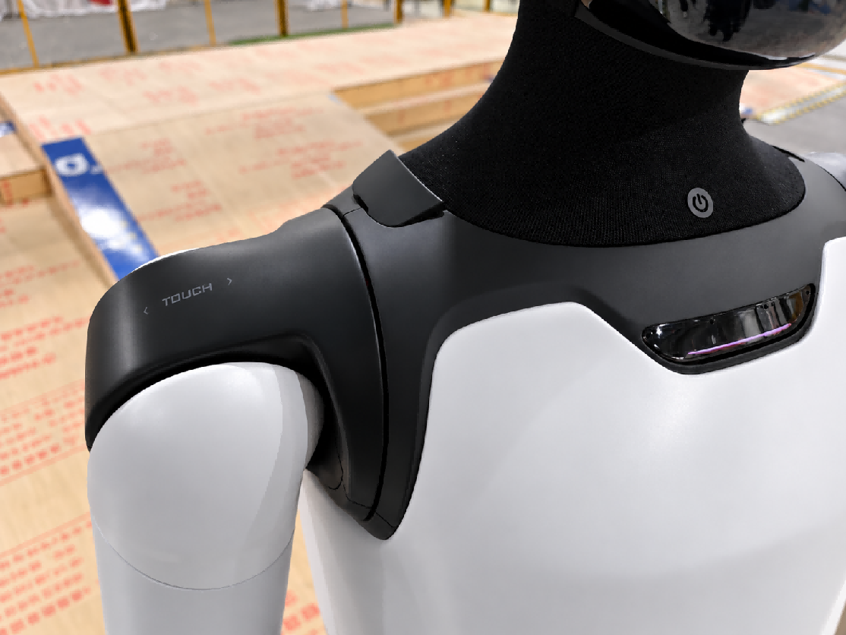
• Step 2: Hold the ring end and align the buckle end with the slot and press it firmly
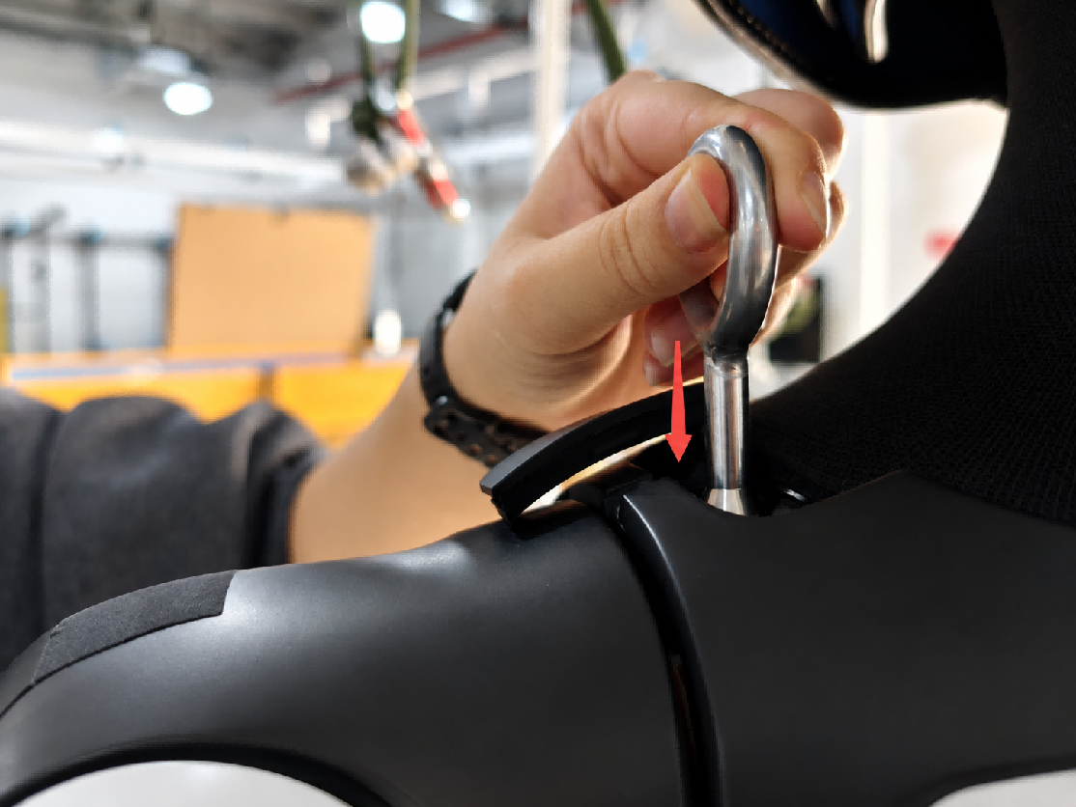
• Step 3: Rotate the lifting ring 90° and leave it there
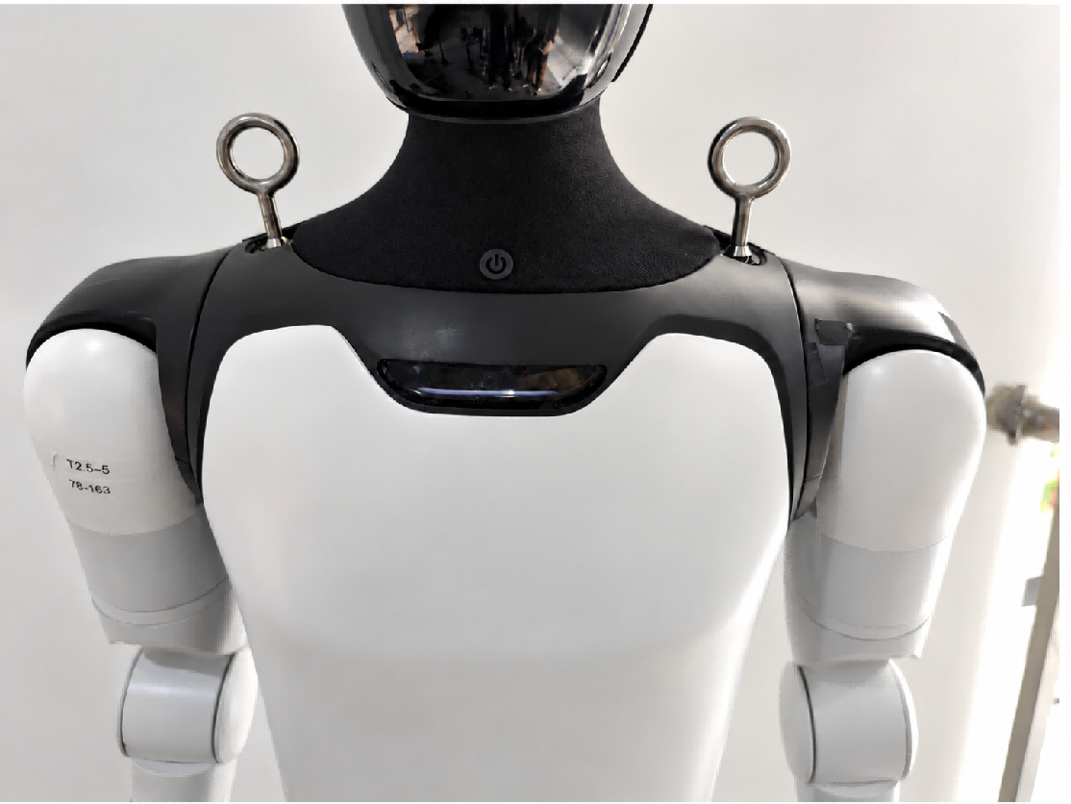

5. Function Description

5.1 Full-Body Dance
In the Talent screen of the skill operation navigation bar, select the corresponding dance content and swipe to play.
Step 1: Tap the top tab bar and select [Skills]
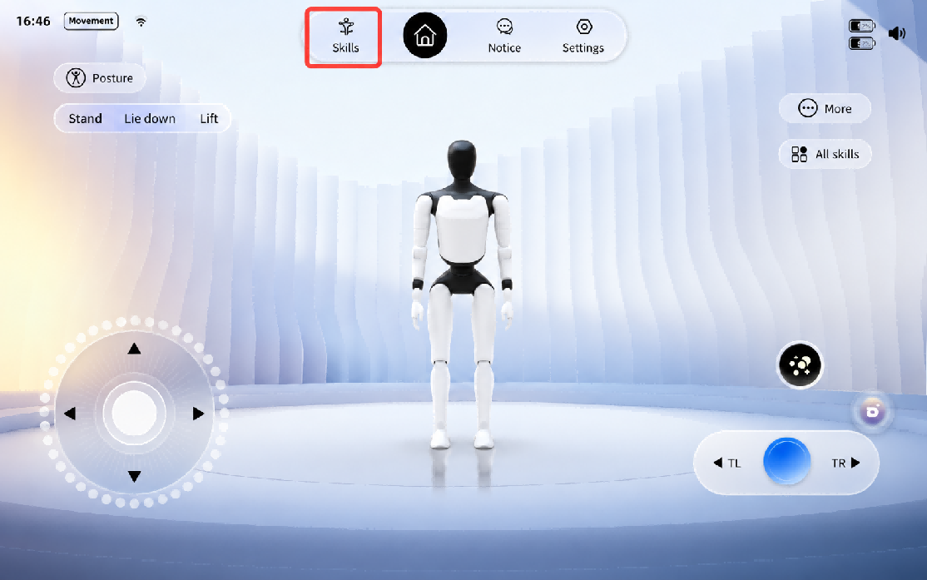
Step 2: Select the desired dance, and swipe to execute
⚠️ Note: Different dances must be confirmed and executed according to their respective pop-up instructions. Follow the prompts to ensure safety.

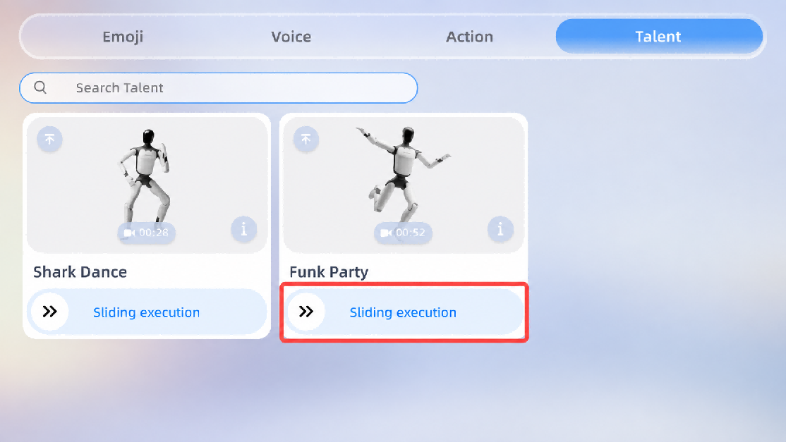

5.2 Body Actions

5.2.1 Upper-Limb Actions
On the client home page, tap Skills > Resource Management, then select an action to play.
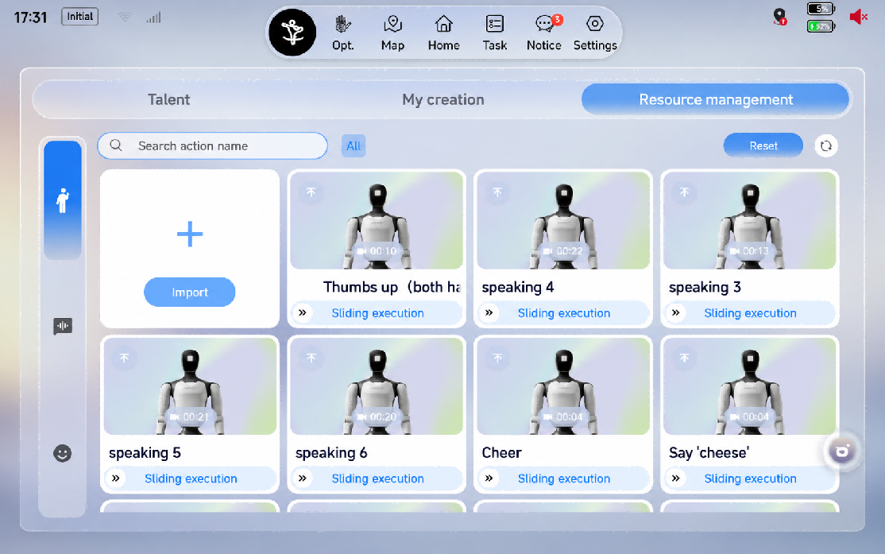

5.2.2 Upper-Limb Compliant Motion Playback (Passive Safety)
When this switch is turned on, the robot's arms become compliant, which reduces collision force.

5.2.3 Upper-Limb Motion Perception-Based Obstacle Stop (Active Safety)
When this switch is turned on, if you stand within the range of the robot's motion, the arm will pause for your safety (staying within 20 cm of the robot may affect the obstacle-stop performance).
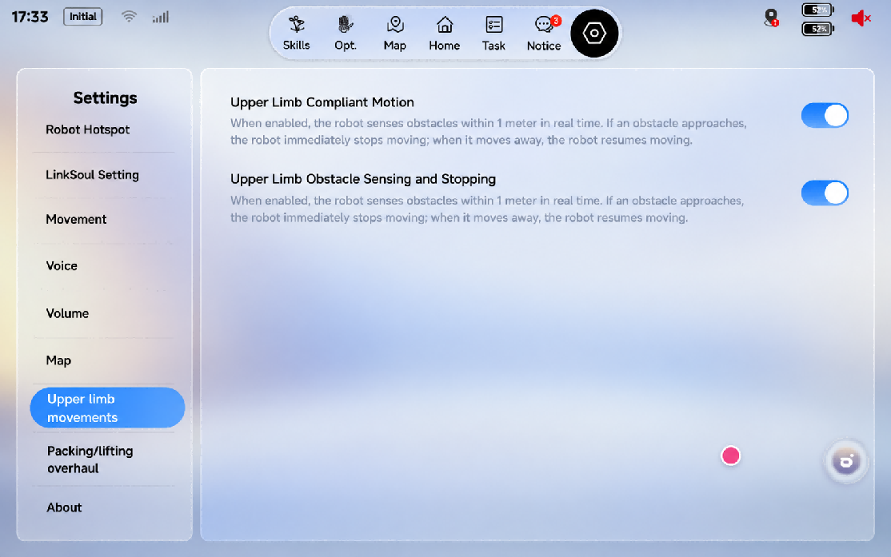

5.3 Navigation and Obstacle Avoidance
The switch is on by default. Once you turn it off, the robot will no longer avoid obstacles, posing a collision risk — please use this option with caution.
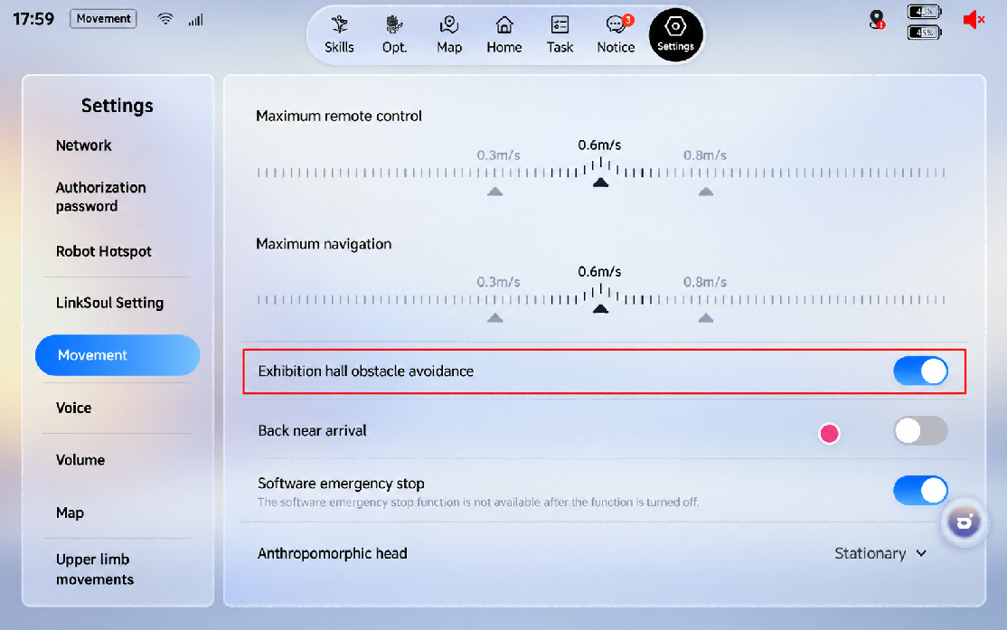

5.4 Lively Standby
The [Lively Standby] switch is off by default. It can be enabled under [Settings] > [Upper-Body Actions] > [Lively Standby] in the App.

5.5 Robot Interaction
1. Two voice interaction inputs are available: [Built-in Mic] and [External Mic], which can be switched in the voice settings on the client.
2. Voice control of motions, dances, walking, and volume is supported, for example "Please shake hands", "Give me a dance", "Walk forward", "Set the volume to half", and "Set the volume to 30".
3. A newly added mute / interaction-disabled expression layer design (top-left corner of the screen), plus two new immersive expressions: entering the out-of-body avatar and the out-of-body avatar's ultimate move.
4. Multilingual interaction is supported, covering 16 languages including Chinese, English, German, French, Spanish, Japanese, Korean, Portuguese, Italian, Arabic, Thai, Russian, Malay, Vietnamese, Indonesian, Kazakh, and Turkish. Except for Chinese and English, the recognition rate of the other languages is approximately 65%–85%.
5. Speaker recognition is supported. Based on sound-source localization and visual information, the robot achieves "look at whoever is speaking" — turning its head / waist / whole body toward the user — and "knows who is speaking": for users with face ID, All-New Futurist Ultra can politely address them by name during wake-up responses and LLM chats. In complex environments with medium-to-high noise and multiple people, occasional positioning errors may occur; the [Interaction Full-Body Follow] switch under Client → [Voice] can be turned off.
6. Additional features will be added in subsequent OTA updates. For details, refer to the release notes of each version.

5.6 Spatial Tasks

5.6.1 Mapping and Point Marking
1. Open the client and enter the Map module.

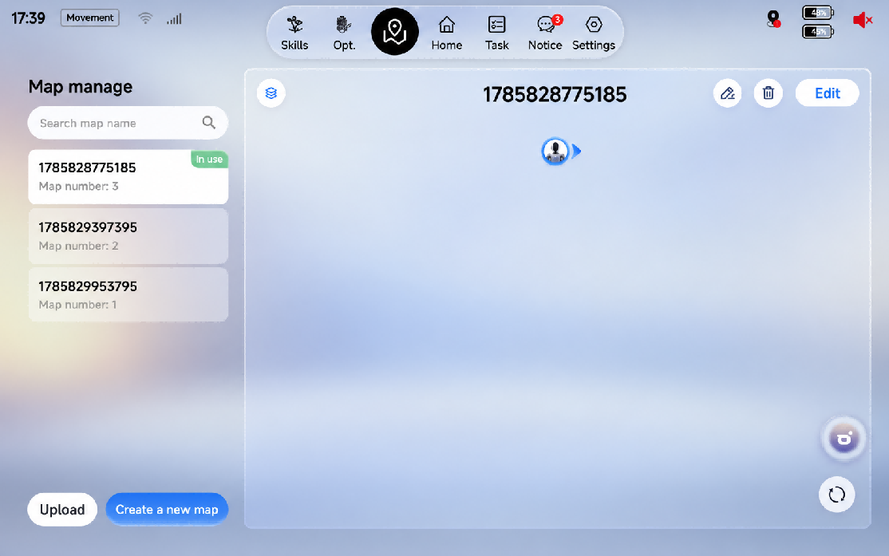
2. Tap Create Map and complete mapping of the exhibition area.
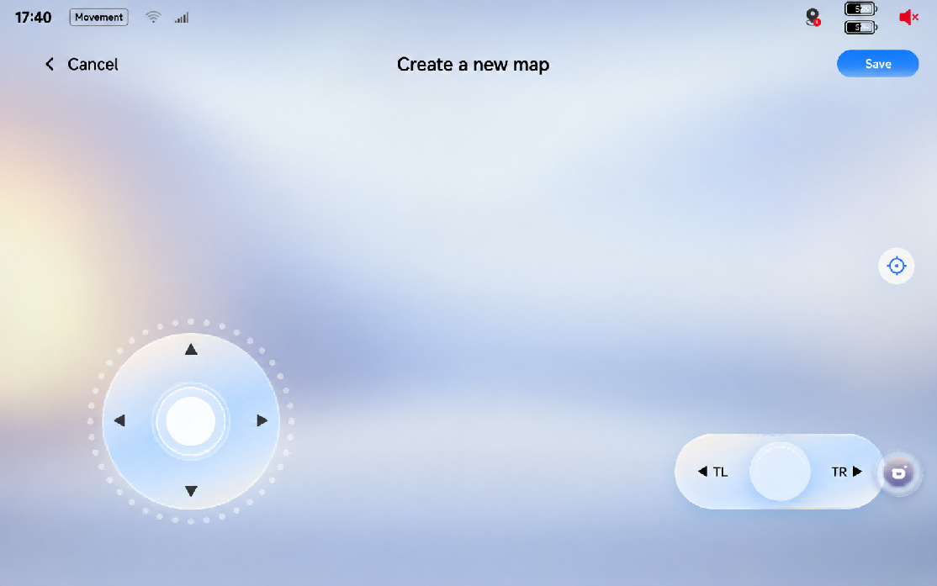
3. Enter Edit → Points and mark each explanation point on the map.
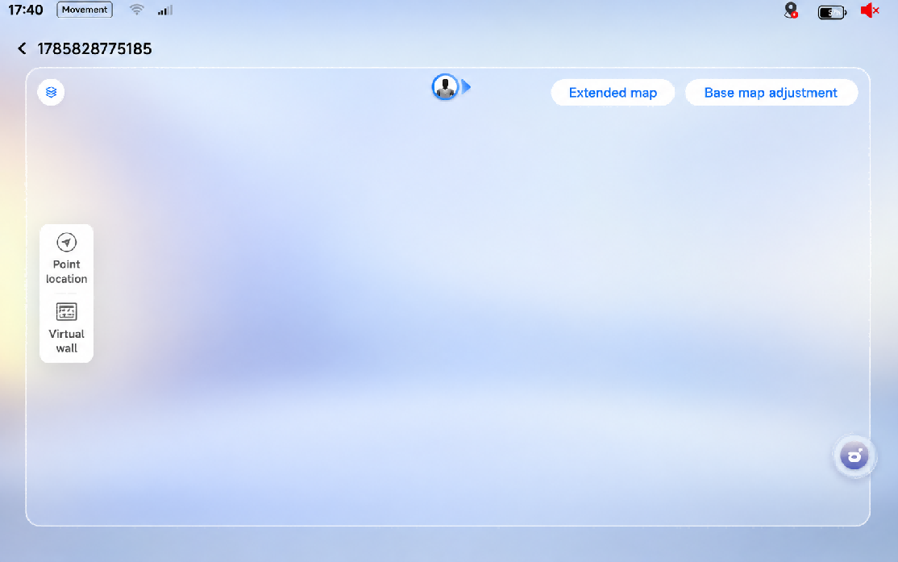
4. After editing, upload the map to the cloud.
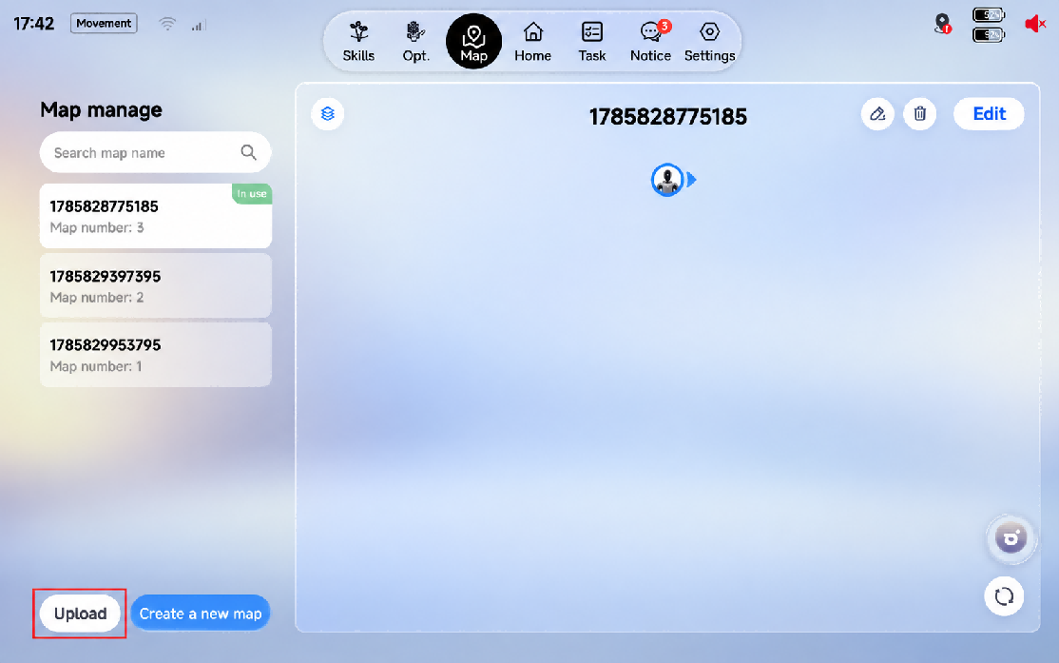

5.6.2 Post-Deployment Verification
Task deployment confirmation. Open the client, enter the Task module, and confirm that the latest deployed spatial task is visible.
After receiving the task, trigger the spatial task in the following three ways to verify that the function works properly:
Trigger Method | Verification
Client trigger | Trigger the spatial task manually in the client app and confirm the task starts normally
Voice trigger | Trigger the spatial task with a voice command and confirm voice recognition and task startup work normally
Shoulder-tap trigger | Trigger the spatial task by tapping the robot's shoulder and confirm motion recognition and task startup work normally

Pass criteria: the robot can execute the exhibition explanation task normally along the preset route and points.

5.6.3 Client Trigger Method
Tap the filter to show the required map. Deployed tasks will appear here. Then, tap [Start] under a task, and the robot will begin executing that task.
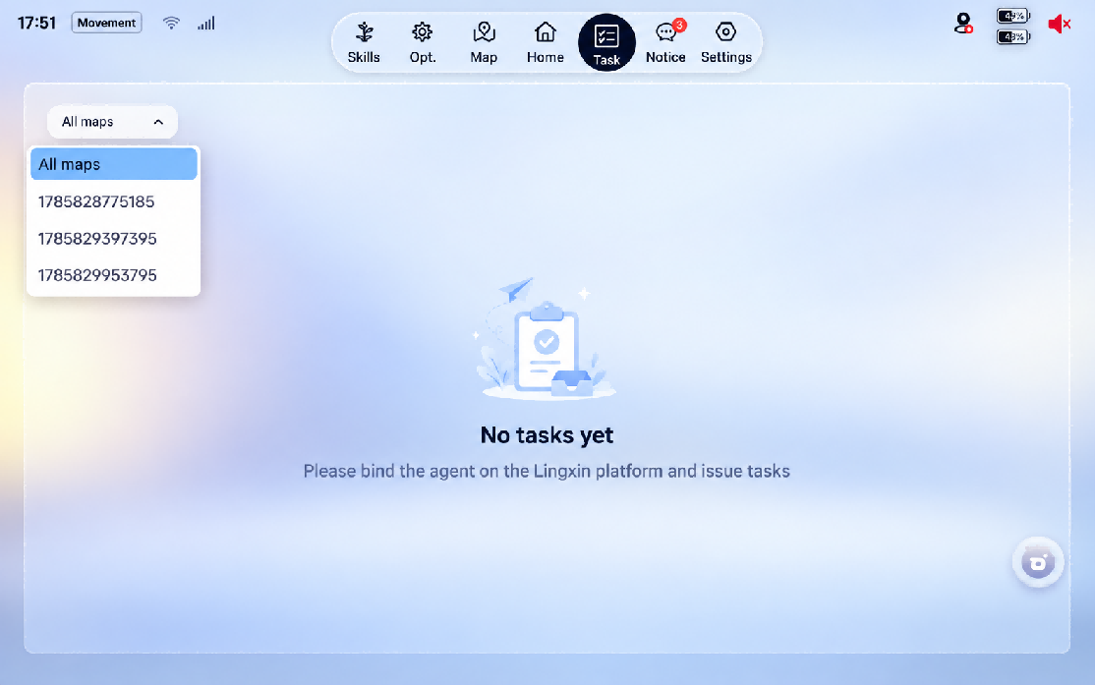

5.7 Fleet Control

5.7.1 How to Obtain
Please contact after-sales personnel to obtain the "Fleet Control software package".

5.7.2 Project Management
Each project is a separate engineering file. After creation, it can be shared among multiple people through export and import.
• Create New Project: Tap the Create New Project button to create a new project.
• Export: Tap the Export button in the top-right corner, select the file to export and name it, to generate a .gcs file.
• Import: Tap [Import Existing Project] and select a .gcs file to quickly open an exported project.
• View Project History: Displays previously edited projects; tap to open a project.
• Delete Project History.
Note: Due to the refactoring of the software interface, projects from historical versions (before v1.2) can no longer be opened.

5.7.3 Robot Management
• Add Robot: Tap the [Add Robot] button and fill in the relevant information according to the input box prompts. Multiple robots can be added at once, in the format: "All-New Futurist @ Robot Nickname @ IP".
Robot status:
1. Robot nickname (the name given when adding the robot)
2. The robot's current Action
3. The task the robot is currently executing (this task is a multi-robot control task)
4. Robot status (latency with the current computer, manual/automatic state, emergency stop state, Wi-Fi signal, battery information, etc.)
5. The correction effect after time synchronization
6. The reconnect button, etc.
• Function Buttons: The checkbox at the front of the card has two states, selected or unselected; this box affects the scope of functions such as deletion, time synchronization, and resource synchronization. To quickly select only one robot and set all other robots to unselected, double-click that robot's card.
• Time Synchronization: Using this function calculates the time difference interval of the selected robots and caches this data.
Note: When you need to control multiple robots for synchronized operation, be sure to tap Time Synchronization in advance; it can be performed multiple times.

5.7.4 Menu Bar
Tap the top-left corner to show the menu bar.
• "Execute After": Sets the preparation time before a task is executed (when the network condition is poor, a longer preparation time can be set to ensure that the robots execute commands simultaneously).
• "Close Project": Ends the current project and returns to the home page.

5.7.5 Audio
Tap [Import Audio].
• Local Audio: Select and upload a file. The program will automatically convert it to a format supported by the robot. The name of the selected audio file is filled in by default during import and can be changed; when files have duplicate names, the new resource will overwrite the existing audio resource.
• Text-to-Speech (TTS): Enter text and call the TTS service (ensure network connectivity) to generate audio; the audio must be named manually.
• Tap [Sync Audio Resources to Robots] to sync all audio resources to the robots, with the robot scope being the robots selected previously.
Note: Synchronization is required each time after adding audio resources.

5.7.6 Automatic Tasks
❗ Before starting control with Multi-Robot Control, ensure the robots are idle (not walking, performing actions, dancing, etc.).

If abnormal operation occurs, restart the software; data will not be lost.

5.7.6.1 Roles
• Roles can be created using the [Add Role] button on the left side of the timeline. Each role generates one task track.
Role card functions:
1. Tap the [Selection Box] to adjust which robots are bound to this role, within the scope of the preceding robot list.
2. Press and hold the card to drag it and adjust the order of the roles up and down.
3. Tap the [Delete] icon to delete a role and all its associated content, without affecting the robot itself.
4. Tap the [Copy] icon to copy this role's tasks to other roles.
5. Tap the [Hide] icon (a special state) to temporarily hide a role; when a task is issued, this role will not participate in execution.

5.7.6.2 Task Orchestration
Each role has its own timeline, and each role can run five types of task commands simultaneously:
1. Audio: Audio created in audio management; its duration is fixed to the audio length. Audio tasks can overlap, and the later overlapping audio task interrupts the playback of the previous one, but two audio tasks cannot be created to start at the same time.
2. Expression: A task from the robot's expression list; the expression plays in a loop until the next expression task starts.
3. Action: A task from the robot's action/dance list; the action duration is the action's fixed length. Tasks can overlap, and the later overlapping action task interrupts the playback of the previous one, but two action tasks cannot be created to start at the same time.
4. Movement: Properties such as walking speed, turning, and time of the task can be set.
5. Status: Currently supports Action switching, volume setting, and microphone on/off.

5.7.6.3 Create / Edit Tasks
• Right-click a task to show the Edit, Copy, and Delete buttons:
• Edit: Tap to bring up the edit dialog to modify task information.
• Copy: Copies the task information.
• Delete: Deletes the task (after selecting the command, pressing the keyboard Delete key also deletes it).
• Right-click a blank area to show the Create and Paste buttons:
• Create: Tap to bring up the create dialog to quickly create task information.
• Paste: Tap to quickly create a task by pasting the copied task.

5.7.6.4 Execute / Cancel Tasks
• Tap [Execute Task] in the top-right corner and confirm.
• The task delivery progress and execution countdown are shown; to cancel a task, tap the [End] button in the top-right corner before the execution countdown ends.
• Stage Preview.

6. Accessories Management and Usage

6.1 4G/5G Module User Guide
Robots are equipped with built-in eSIM cards. For details on the specific configuration and warranty services, please refer to Section 8.1 of this document.

6.1.1 eSIM Usage Instructions
• Communication standard: Supports 5G/4G.
• Plan: 100 GB of data per month. Once the data is used up, mobile network service stops; to continue using it, contact FF EAI Robotics after-sales to purchase a data add-on package.
• Free period: Up to 1 year. To continue using it after expiry, contact FF EAI Robotics after-sales to renew.
• Activation: Automatically activated after the device powers on.
• Network usage: The eSIM is enabled by default. When the device connects to Wi-Fi, the Wi-Fi network is used preferentially; when Wi-Fi disconnects, the mobile network is used automatically.

6.1.2 SIM Card Specifications
The All-New Futurist Ultra supports Micro-SIM cards for internet access. Its cellular communication module is compatible with 4G/5G protocols, and supports carriers including China Mobile, China Unicom, and China Telecom.

6.1.3 SIM Card Purchase
Because some functions of the All-New Futurist Ultra require access to FF EAI Robotics' servers, whitelist configuration is required, and a dedicated enterprise IoT card must be purchased from an FF EAI Robotics partner. The advantage of an enterprise IoT card is that no personal real-name verification is required—only the business license and the front and back of the legal representative's ID are needed. In addition, it supports a unified card management platform that can monitor in real time the card's order and delivery status, data usage, balance and renewal, etc.

6.1.4 SIM Card Insertion
Flip the head upward and insert the SIM card into the corresponding slot from the neck of the robot.
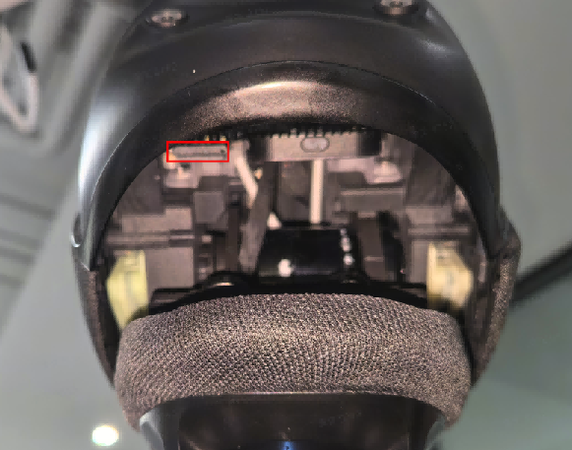

7. Daily Maintenance and Management
1. Safety Warnings
• a. Power-off Maintenance: Before any maintenance or component replacement, completely power off the device and confirm it is in a fully de-energized safe state.
• b. No Unauthorized Modification: Do not modify the robot or alter its original design and configuration without authorization.
• c. Professional Repair Only: Do not disassemble the robot personally. If maintenance is required, contact the manufacturer's designated professional service personnel.
2. Maintenance and Upkeep
• a. Routine Maintenance: Perform regular maintenance in accordance with the manufacturer's (FF EAI Robotics) recommendations to keep the robot in optimal operating condition.
• b. Use Original Spare Parts: Only use manufacturer-specified original spare parts for component replacement to guarantee equipment performance and operational safety.
3. Fault Handling
• a. Fault Response: Immediately stop operation once any malfunction occurs during operation, and notify professional technicians to conduct inspection and repair.
• b. No Unauthorized Disassembly & Repair: Do not disassemble or attempt to repair the robot by yourself, so as to prevent further damage.
4. Battery and Power Management
• a. Safe Charging: Do not disassemble the battery for separate charging; charge only by connecting the power supply.
• b. Charging Environment: The robot's battery shall be charged in a safe, dry environment. Avoid humid and high-temperature surroundings.
• c. Prevent Overcharging: Do not keep the device connected to power for a prolonged period to avoid battery overcharging and overheating, and to prolong battery service life.
• d. Battery Replacement: Battery replacement must be performed only by qualified professionals. Using a charger for one battery type on another may cause fire hazards.
• e. Dedicated Power Supply Only: Use only the supplied removable power supply unit for charging.
• f. Battery Disposal: Remove the battery and dispose of it in accordance with safety regulations before scrapping the device.
5. Software Management
• a. Regular Updates: Regularly check and update the robot's operating system and control software to fix vulnerabilities and enhance security.
Note: Compliance with the above instructions ensures safe and efficient operation of the robot. For any inquiries, please contact the manufacturer or authorized service provider for support.

8. After-sales Service Policy

8.1 Warranty Content
For details of the warranty content, please refer to https://support.ff.com/us/

8.2 App Privacy Policy
Welcome to the App. The App and its related services (the "Products and Services") are developed and operated by FF AI-Robotics Inc. ("we" or "us"). We fully understand the importance of protecting the personal information and privacy of users ("you"). This Privacy Policy ("this Policy") sets out the rules governing how we collect, use, store, and protect your personal information when you access and use our Products and Services.
Please read this Policy carefully and make sure you fully understand all of its rules and key points (especially those presented in bold) before using our Products and Services. If you do not agree with this Policy or any of its terms, you should stop using our Products and Services. Once you choose to use them, you are deemed to have fully read and agreed to all contents of this Policy.
This policy helps you understand:
a. How we collect and use your personal information
b. How we share, transfer, and disclose your personal information
c. How we use cookies and similar technologies
d. How we store your personal information
e. How we protect your personal information
f. How we protect the personal information of minors
g. Your rights
h. How this Policy is updated
i. Contact us
1. How we collect and use your personal information:
In accordance with applicable laws and regulations, and strictly following the principles of legitimacy, lawfulness, and necessity, we collect and use the personal information you actively provide or that is generated when you use our Products and Services, in order to provide you with better products and services.
a. When you register for or log in to an account, we collect the username, phone number, and other information you provide, and may verify your identity via SMS or email.
b. When necessary, we verify your true identity to comply with laws, regulations, and regulatory requirements and to ensure user security.
c. When you contact us, we save your call records, call content, or contact information so that we can reach you, resolve issues, and record the handling plan and results.
2. How we share, transfer, and disclose your personal information:
Circumstances requiring your prior authorization or consent — we may share, transfer, or disclose your personal information to third parties in the following circumstances:
a. As provided in this Policy or upon your explicit consent or authorization;
b. As required by applicable laws and regulations, legal procedures, or mandatory administrative or judicial requirements;
c. To the extent permitted by laws and regulations, to protect the interests, property, or safety of us, our affiliates, you, other users, or the public from harm;
d. To implement functions related to the Products and Services or to provide the services you request;
e. For use in academic research;
f. Where you have violated this Policy and we provide information to third parties for the purpose of protecting our rights.
Circumstances not requiring your prior authorization or consent — we may share, transfer, or publicly disclose your personal information without your prior authorization or consent in the following circumstances:
a. Where necessary to perform statutory duties or obligations, such as duties or obligations directly related to national security, defense security, criminal investigation, prosecution, trial, and execution of judgments;
b. Where it is necessary to protect the vital interests of life or property of you or other individuals but it is difficult to obtain your consent;
c. Personal information that you have voluntarily disclosed to the public;
d. Personal information collected from lawfully public information, such as lawful news reports or government information disclosure;
e. Where necessary to conclude and perform a contract at your request;
f. Where necessary to maintain the safe and stable operation of the Products or Services, such as discovering and handling faults;
g. Personal information that has been technically processed so that the recipient cannot re-identify a specific individual and cannot restore it; or personal information that we have de-identified in order to improve products and services;
h. Other circumstances stipulated by laws and regulations.
3. How we use cookies and similar technologies:
Cookies and similar technologies are common technologies used on the Internet. When you access our Products and Services, we may use such technologies to send one or more Cookies or anonymous identifiers to your device to collect and store information about your access to and use of our Products and Services. They will not be used for any purpose other than those described in this Policy, mainly to achieve the following functions:
a. Ensuring the secure and efficient operation of the Products and Services: setting authentication and security Cookies or anonymous identifiers to confirm whether you are safely logged in, to distinguish whether you have encountered account theft, fraud, or other unlawful acts, and to improve service efficiency and login and response speed;
b. Helping you enjoy easier access: eliminating the need to repeatedly fill in personal information or enter search content;
c. Clearing Cookies: most browsers provide the function of clearing cached data; you can clear Cookies in your browser settings, but after clearing, functions or services that rely on Cookies may become unavailable.
4. How we store your personal information:
a. In accordance with laws and regulations, we store the personal information collected and generated during operation within the People's Republic of China. At present, such information will not be transferred overseas; if overseas transfer is required, we will follow relevant national regulations or seek your consent.
b. We retain your personal information only for as long as necessary to provide the Products and Services. Beyond the necessary period, your personal information will be deleted or anonymized, unless retention is extended based on your needs or as permitted or required by laws and regulations.
5. How we protect your personal information:
a. We attach great importance to the security of your personal information and will strive to take reasonable technical and administrative security measures to prevent your personal information from being improperly used or from being accessed, publicly disclosed, used, modified, damaged, lost, or leaked without authorization.
b. You should understand that although we have taken reasonable and effective measures and comply with the standards required by relevant laws, due to technical limitations and possible malicious means, the absolute security of information cannot always be guaranteed.
c. In the event of a user information security incident, we will, in accordance with laws and regulations, promptly inform you via push notifications, email, letters, SMS, or other means of the basic situation and possible impact of the incident, the measures taken or to be taken, suggestions for you to prevent and mitigate risks on your own, and remedial measures for you. Where it is difficult to notify each user individually, we will issue an announcement in a reasonable and effective manner. We will also report the handling of the incident to the relevant regulatory authorities as required.
6. How we protect the personal information of minors:
a. If you are a minor under the age of 18, you should read and agree to this Policy under the supervision and guidance of your parents or other guardians before using our Products and Services. If your guardian does not agree to your use of our Products and Services under this Policy or to your provision of personal information to us, please stop using our Products and Services immediately and notify us promptly to delete your personal information.
b. If you are the guardian of a minor and have questions about the processing of the minor's information under your guardianship, or if the minor under your guardianship uses our Products and Services or provides personal information without your consent, please contact us through the methods described in this Policy so that we can take appropriate measures.
7. Your rights:
We attach great importance to your management of personal information and do our utmost to protect your rights relating to your personal information:
a. Changing or withdrawing the scope of authorization: You can turn off relevant permissions in the product's operating system, change the scope of consent, or withdraw your authorization. After withdrawal, we will no longer collect information related to those permissions. Certain business functions and services require your information to complete; after you withdraw consent or authorization, we will be unable to continue providing the corresponding services and will no longer process your relevant personal information. However, your withdrawal does not affect the collection, processing, and use of information previously carried out based on your authorization.
b. Account cancellation: If you wish to cancel your account, please contact us through the methods described in this Policy, and we will process your request promptly. Before canceling your account, we may verify your identity, security status, device information, etc.; you agree to authorize and cooperate with our account cancellation process. After your account is canceled, we will delete or anonymize your personal information in accordance with this Policy, except as otherwise provided by laws and regulations.
c. Other rights related to personal information: If you believe that your personal information rights may have been infringed or wish to exercise other rights related to personal information, you may contact us through the methods described in this Policy, and we will respond promptly after receiving your request, except as otherwise provided by laws and regulations.
8. How this Policy is updated:
a. We have the right to modify, supplement, or update this Policy from time to time and publish it in an appropriate manner. For major changes, we will also provide more prominent notice (such as official announcements, push notifications, SMS, or email).
b. If you choose to continue using our Products and Services, you must re-agree to the revised contents of this Policy. Please pay attention to and stay informed about revisions; if you do not agree with the revised version, you should immediately stop using the Products and Services we provide.
c. Major changes referred to in this Policy include, but are not limited to:
▪ Major changes to our service model, such as the types, purposes, and methods of processing personal information;
▪ Changes to the main recipients of personal information sharing, transfer, or disclosure;
▪ Major changes to your rights regarding the processing of personal information and how to exercise them;
▪ Changes to the department responsible for personal information security, contact information, and complaint channels;
▪ When a personal information security impact assessment report indicates high risk.
9. Contact us:
If you have any questions, comments, or suggestions about this Policy, you can contact us in the following ways:
a. After-sales support: support.ff.com
b. After-sales email: support@ff.com
We will respond to your questions, comments, or suggestions promptly and help resolve your issues.

